© 2013 Infosys Limited. Strictly private and confidential. No part of this document should be reproduced or distributed without the prior permission of Infosys Limited.

| D:\Official\Brand identity elements 2013\Logo horizontal\Finacle-Master_natural_horz_BTE.gif | |
| --- | --- |
|  |  |
|  | Technical Release Document For  MDPC-678 – POS Clearing Load >> End of Day Batch |

**Document History**

|  |  |  |  |  |
| --- | --- | --- | --- | --- |
| **Ver. No.** | **Date** | **Author** | **Description** | **Reviewed By** |
| 1.0 | 12th December ,2021 | Hrishikesh Zagade | MDPC-678 – POS Clearing Load >> End of Day Batch |  |
| 1.1 | 17 December,  2021 | Hrishikesh Zagade | MDPC-678 – POS Clearing Load >> End of Day Batch - Devolution |  |

Table of Contents

[1. Scope of Sprint 4](#_Toc37343407)

[1.1 Solution 4](#_Toc37343408)

[2.1 Setups 5](#_Toc37343409)

[2.1.1 CPARAM setup 5](#_Toc37343410)

[2.1.2 ARC set up 5](#_Toc37343411)

[2.1.3 MLRC set up 5](#_Toc37343412)

[2.1.3 HPTTM set up 6](#_Toc37343413)

[2.1.4 Batch Setups 6](#_Toc37343414)

[2.1.5 Reports 6](#_Toc37343415)

[2.1.6 CUSTOM MAP 6](#_Toc37343416)

[2.1.7 CUSTOM JAR 6](#_Toc37343417)

[2.1.8 ENVIRONMENT VARIBLE 6](#_Toc37343418)

[3. Source Files 7](#_Toc37343419)

[3.1 Source File Details 7](#_Toc37343420)

[4.1 Release Impact 8](#_Toc37343409)

[4.1.1 Modules 8](#_Toc37343410)

[4.1.2 Menus 8](#_Toc37343412)

[4.1.3 APIs 8](#_Toc37343413)

[4.1.4 Custom Components 8](#_Toc37343415)

[4.1.5 Scripts 8](#_Toc37343416)

[4.1.6 Reports 8](#_Toc37343417)

[4.1.7 EOD Batches 8](#_Toc37343418)

[4.1.8 EOD Batches 8](#_Toc37343418)

# Scope of Sprint

|  |  |  |
| --- | --- | --- |
| **Backlog No.** | **Req Ref Num** | **Req Description** |
|  | MDPC-678 | POS Clearing Load >> End of Day Batch |

## Solution

1. Finacle will process and validate the Input file from CMS .
2. The details in the input file are validated and response message and response code are updated.
3. Finacle sends an output file along to CMS after successful file processing.

2. Configuration Setups

2.1 Setups

2.1.1 CPARAM setup

|  |  |  |  |  |  |  |
| --- | --- | --- | --- | --- | --- | --- |
| **Req Ref Num** | **Parameter Id** | **Parameter Level** | **Parameter Value** | **Module Name** | **Parameter Desc.** | **Bank Id** |
| MDPC-678 | POS\_ADQUIRENTE\_REQUEST | BNKL | The value can be given as per the bank’s suggestion. | LIABILITIES | POS ADQ Request Path | BAZMX |
| POS\_PROSA\_REQUEST | BNKL | The value can be given as per the bank’s suggestion. | LIABILITIES | POS PROSA Request Path | BAZMX |
| POS\_EGLO\_REQUEST | BNKL | The value can be given as per the bank’s suggestion | LIABILITIES | POS EGLO Request Path | BAZMX |
| POS\_ADQUIRENTE\_RESPONSE | BNKL | The value can be given as per the bank’s suggestion | LIABILITIES | POS ADQ Response Path | BAZMX |
| POS\_PROSA\_RESPONSE | BNKL | The value can be given as per the bank’s suggestion | LIABILITIES | POS PROSA Response Path | BAZMX |
| POS\_EGLO\_RESPONSE | BNKL | The value can be given as per the bank’s suggestion | LIABILITIES | POS EGLO Response Path | BAZMX |
|  | BAZCOM\_PUR | BNKL | COMBZ01P25 | LIABILITIES | BAZ Com Purchases | BAZMX |
|  | REDCOM\_PUR | BNKL | COMRD01P25 | LIABILITIES | RED Com Purchases | BAZMX |
|  | FOREIGN\_PUR | BNKL | COMEX01P25 | LIABILITIES | Foreign Purchases | BAZMX |
|  | FOREIGN\_PUR\_LOSS | BNKL | DCCOMEEP25 | LIABILITIES | Foreign Exchange Loss | BAZMX |
|  | FOREIGN\_PUR\_GAIN | BNKL | DCCOMEIP25 | LIABILITIES | Foreign Exchange Gain | BAZMX |
|  | BAZCOMDEV\_PUR | BNKL | DVCBZ02P25 | LIABILITIES | BAZ Com Devolution Purchases | BAZMX |
|  | OOFCOMDEV\_PUR | BNKL | DEVCBFPP25 | LIABILITIES | Out-of-policy POS purchase devolution BAZ commerce | BAZMX |
|  | PAYCOMDEV\_PUR | BNKL | PDCBZ02P25 | LIABILITIES | Payment of POS purchase devolution BAZ commerce | BAZMX |
|  | PUR\_DEV\_BAZ | BNKL | DEVCO02P25 | LIABILITIES | POS purchase devolution in BAZ commerce | BAZMX |
|  | OOFREDDEV\_PUR | BNKL | DEVCOFPP25 | LIABILITIES | Out-of-policy POS purchase devolution RED commerce | BAZMX |
|  | PAYREDDEV\_PUR | BNKL | PDCOT02P25 | LIABILITIES | Payment of POS purchase devolution in RED commerce | BAZMX |
|  | DEVINT\_PUR | BNKL | DCOEX01P25 | LIABILITIES | Devolution of international purchases | BAZMX |
|  | DEVINTLOSS\_PUR | BNKL | DEVCOEEP25 | LIABILITIES | Devolution purc in foreign(Foreign exchange loss) | BAZMX |
|  | DEVINTGAIN\_PUR | BNKL | DEVCOEIP25 | LIABILITIES | Devolution purc in foreign(Foreign exchange gain) | BAZMX |
|  | OOFINTDEV\_PUR | BNKL | DCOMEXFP25 | LIABILITIES | Devolution of out-of-policy international purchase | BAZMX |
|  | OOFINTDEV\_PAY | BNKL | PDCOEXFP25 | LIABILITIES | Outofpolicy Int devolution | BAZMX |
|  | DEV\_ANALYSIS\_LIMIT | BNKL | 10000 | LIABILITIES | Devolution Analysis Limit | BAZMX |

### 2.1.2 ARC set up

|  |  |  |  |  |
| --- | --- | --- | --- | --- |
| **Req Ref Num** | **REF Type** | **Code** | **Description** | **Bank Id** |
| NA | NA | NA | NA | NA |

2.1.3 MLRC set up

|  |  |  |  |  |
| --- | --- | --- | --- | --- |
| **Req Ref Num** | **REF Type** | **Code** | **Ref Scheme Type** | **Bank Id** |
| NA | NA | NA | NA | NA |

2.1.3 HPTTM set up

|  |  |  |  |
| --- | --- | --- | --- |
| **Req Ref Num** | **Event Type** | **Event ID** | **Bank Id** |
| NA | NA | NA | NA |

2.1.4 Batch Setups

|  |  |  |  |
| --- | --- | --- | --- |
| **Req Ref Num** | **Job Id** | **Parameters** | **Bank Id** |
| NA | NA | NA | NA |
|  |  |  |  |

### 2.1.5 Reports

|  |  |  |  |  |
| --- | --- | --- | --- | --- |
| **Req Ref Num** | **Template Name** | **Report Format** | **Permission** | **Bank Id** |
|  |  |  |  |  |
|  |  |  |  |  |

### 2.1.6 CUSTOM MAP

NA

### 2.1.7 CUSTOM JAR

NA

### 2.1.8 ENVIRONMENT VARIABLE

NA

|  |  |  |  |
| --- | --- | --- | --- |
| **Req Ref Num** | **Env Var Name** | **Env Var Value** | **Bank Id** |
| NA | NA | NA | NA |

# 3. Source Files

## 3.1 Source File Details

|  |  |  |
| --- | --- | --- |
| **Backlog No.** | **Source Name** | **Deployment Path** |
|  | pos\_Adquirente.scr  pos\_Eglo.scr  pos\_Prosa.scr  pos\_settlement\_FileProcessing.scr  posRecordSettlement.scr  makeTransaction\_CardSettlement.scr  settlementAccountsPOSFetch.scr  posRecordSettlement\_devolucion.scr | /BE/Finacle/FC/app/cust/BAZMX/INFENG/scripts |
| POS\_settlement.com  pos\_settlement\_adq\_inpFileFetch.com  pos\_settlement\_eglo\_inpFileFetch.com  pos\_settlement\_prosa\_inpFileFetch.com  pos\_headerfooter.com | /BE/Finacle/FC/app/cust/BAZMX/INFENG/com |
| POS\_settlement\_CPARAM.sql  CPARAM\_POS\_SETTLE\_UTRANCODES.sql  createTable\_custom\_cust\_pos\_settlement\_file\_tbl.sql  CPARAM\_POS\_SETTLE\_DEVOLUTION.sql  altertable\_ATMPOS\_SETTLEMENT\_FILE\_TBL\_Reconcile.sql | /BE/Finacle/FC/app/cust/BAZMX/INFENG/sql |

**Sanity Steps:**

NA

**FDMS Patch Id order to be deployed**

|  |  |
| --- | --- |
| **FDMS Defect Id** | **Patch** |
|  |  |
|  |  |

[**4.1 Release Impact**](#_Toc37343409)

[**4.1.1** **Modules**](#_Toc37343410)

NA

[**4.1.2**  **Menus**](#_Toc37343412)

NA

[**4.1.3**  **APIs**](#_Toc37343413)

NA

[**4.1.4** **Custom Components**](#_Toc37343415)

NA

[**4.1.5** **Scripts**](#_Toc37343416)

pos\_Adquirente.scr

pos\_Eglo.scr

pos\_Prosa.scr

pos\_settlement\_FileProcessing.scr

posRecordSettlement.scr

makeTransaction\_CardSettlement.scr

settlementAccountsPOSFetch.scr

posRecordSettlement\_devolucion.scr

[4.1.6 Reports](#_Toc37343417)

NA

[4.1.7](#_Toc37343418) Online Batches

NA

[4.1.8 EOD Batches](#_Toc37343418)

NA

# 5. Screen Details

## 5.1 Menu Screenshots

The input file and output file have specific naming convention as follows:

**POS IN**

Archivo/File Prosa: SAC32127H**AAMMDD**ED01.DAT / SAC32127H**211213**ED01.DAT

Archivo/File Eglo: EGBAZ510\_**DDMMAA**01.Txt / EGBAZ510\_**131221**01.txt

Archivo/File Adquirente: BAT1SBAS.321BANCO.D**AAMMDD** / BAT1SBAS.321BANCO.D**211213**

**POS OUT**

Archivo/File Prosa: SAC32127H**AAMMDD**ED01.DAT**.RES** / SAC32127H**211213**ED01.DAT**.RES**

Archivo/File Eglo: EGBAZ510\_**DDMMAA**01.Txt**.RES** / EGBAZ510\_**131221**01.txt.RES

Archivo/File Adquirente: BAT1SBAS.321BANCO.D**AAMMDD.RES** / BAT1SBAS.321BANCO.D**211213.RES**

PFB a sample Input files

Adq input file Eglo input file Prosa input file

  

ADQ output file Eglo output file Prosa Output file

  

PFB the excel which has the format, valid values, length, datatype of all the employee details sent in the input file and response file.

 

Steps for file processing

1. Type env
2. Type exectrusteduser.com sh.com
3. Type com file path. Example: cd /finacle/APPLN/BE/Finacle/FC/app/cust/BAZMX/INFENG/com
4. Type

POS\_settlement.com P (for Prosa)

POS\_settlement.com E (for Eglo)

POS\_settlement.com A (for Adq)

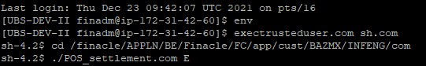

**CMUP SETUP**

User Tran Code : COMBZ01P25

**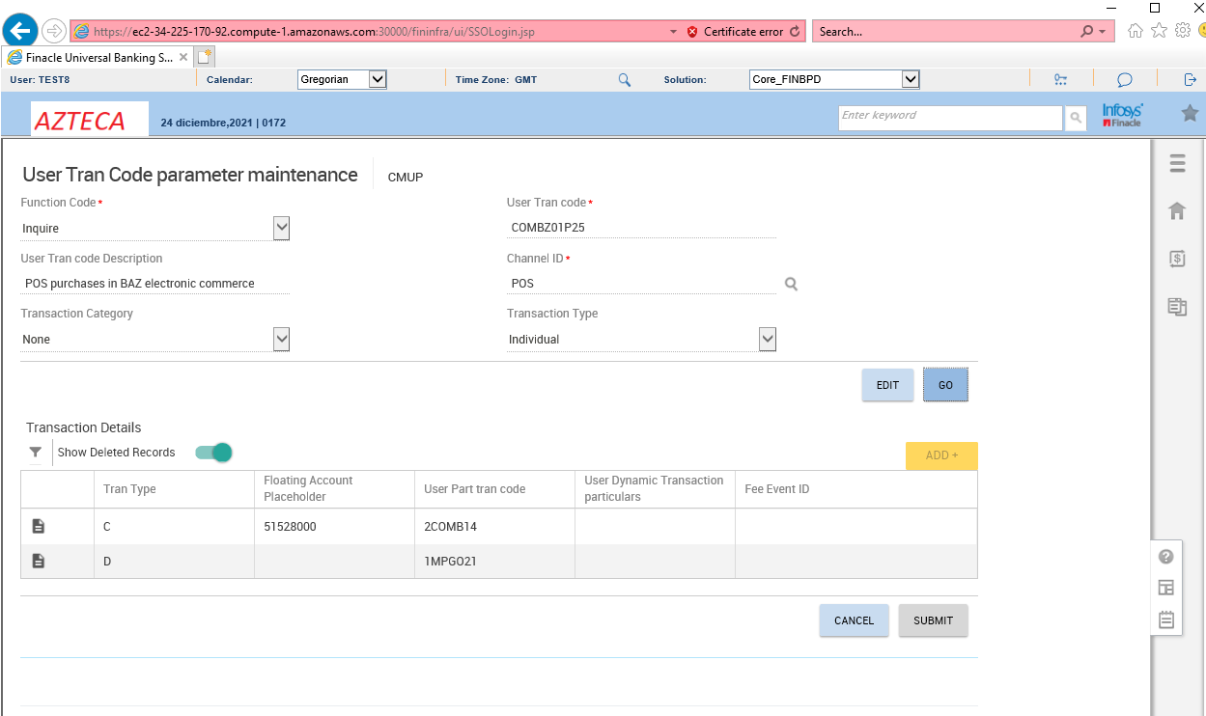**

User Tran Code : INCXCOBP33

**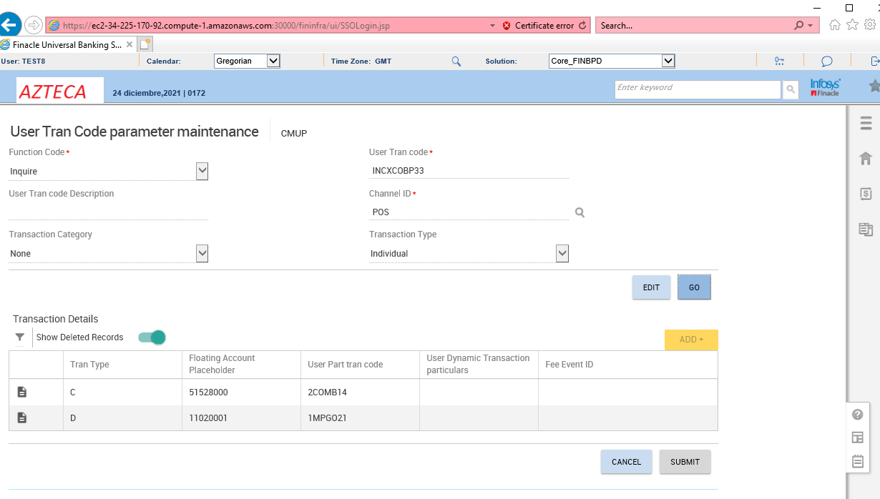**

User Tran Code : INCXCDUP33

**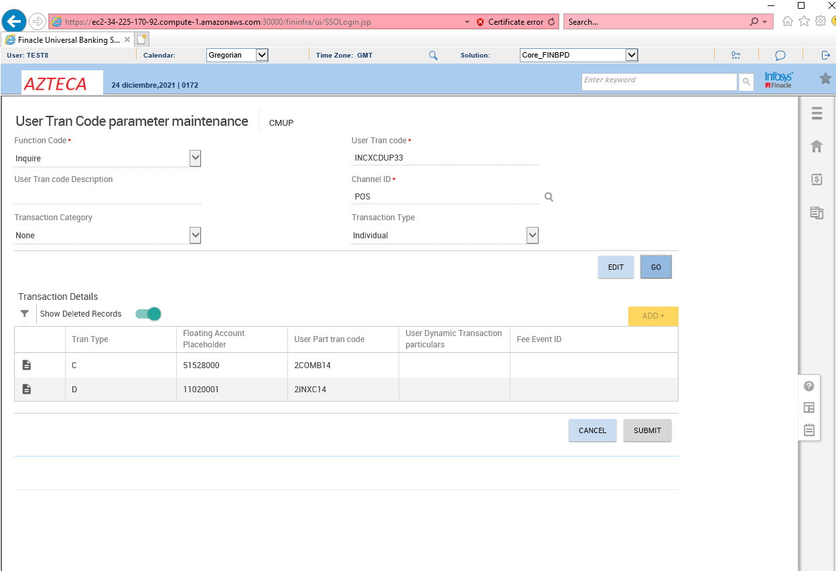**

User Tran Code : COMEX01P25

**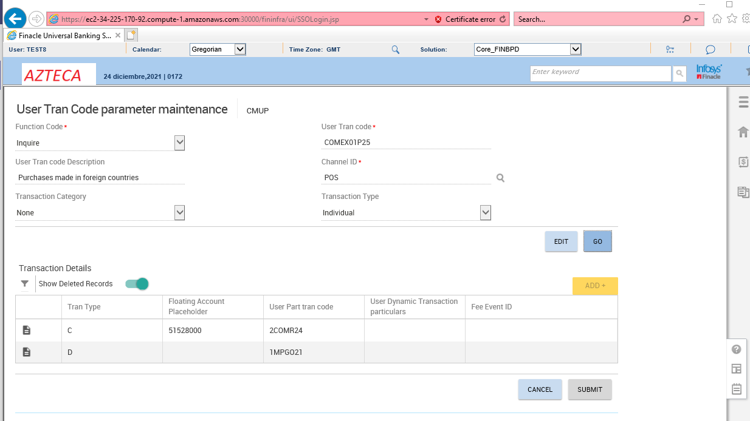**

User Tran Code : **DCCOMEEP25**

**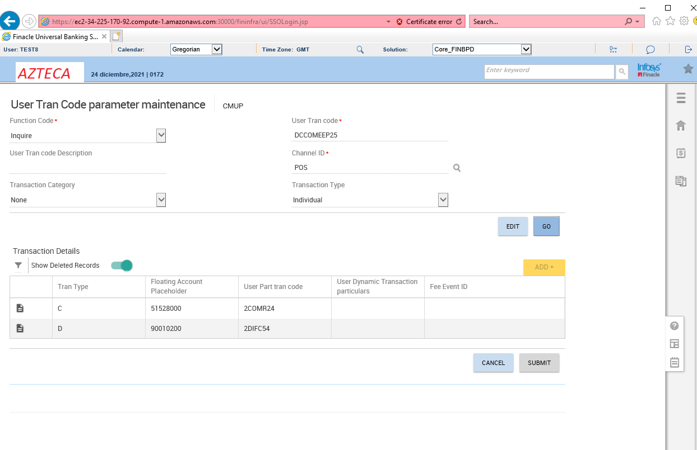**User Tran Code : DCCOMEIP25

**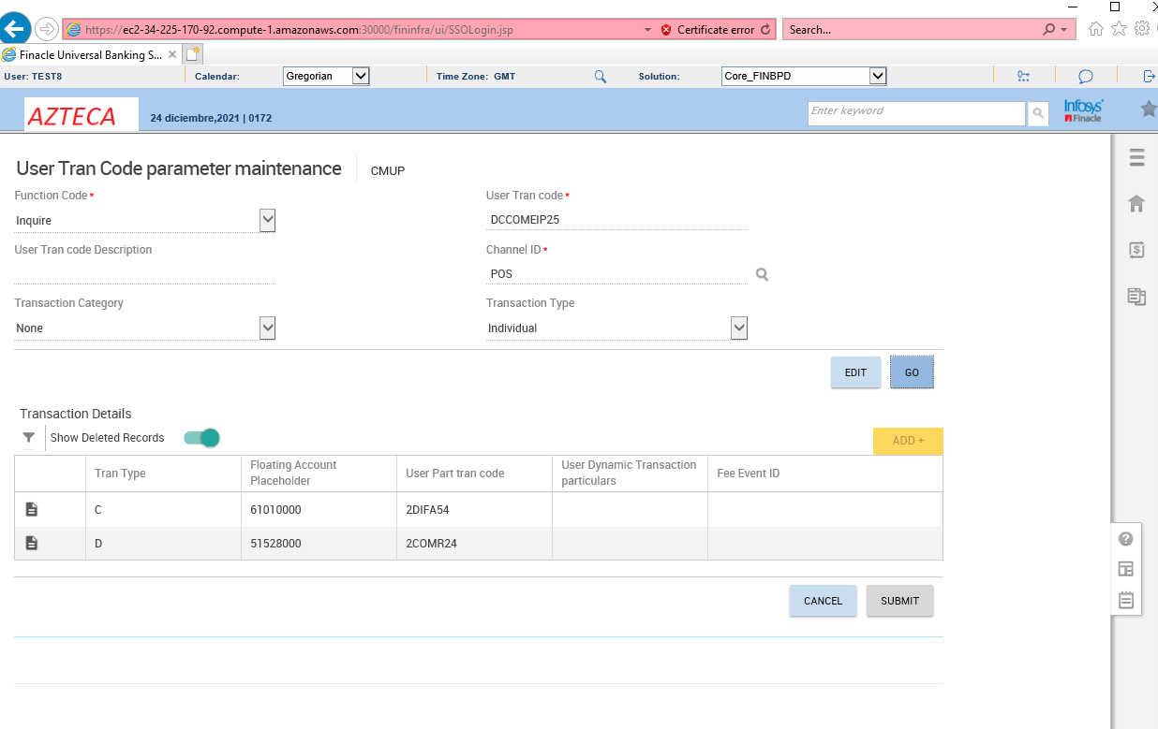**

User Tran Code : COMRD01P25

**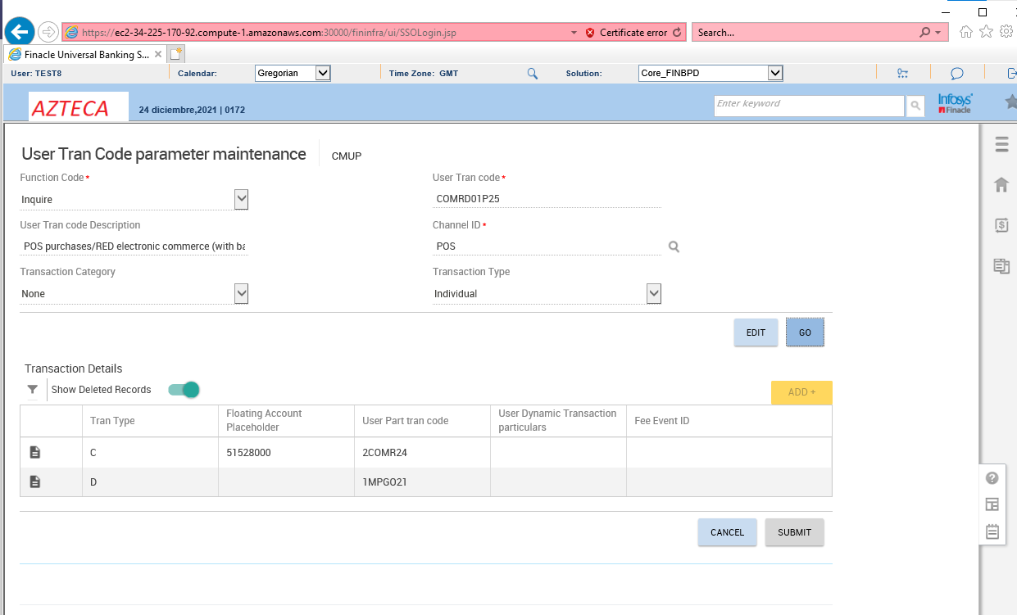**

User Tran Code : DVCBZ02P25

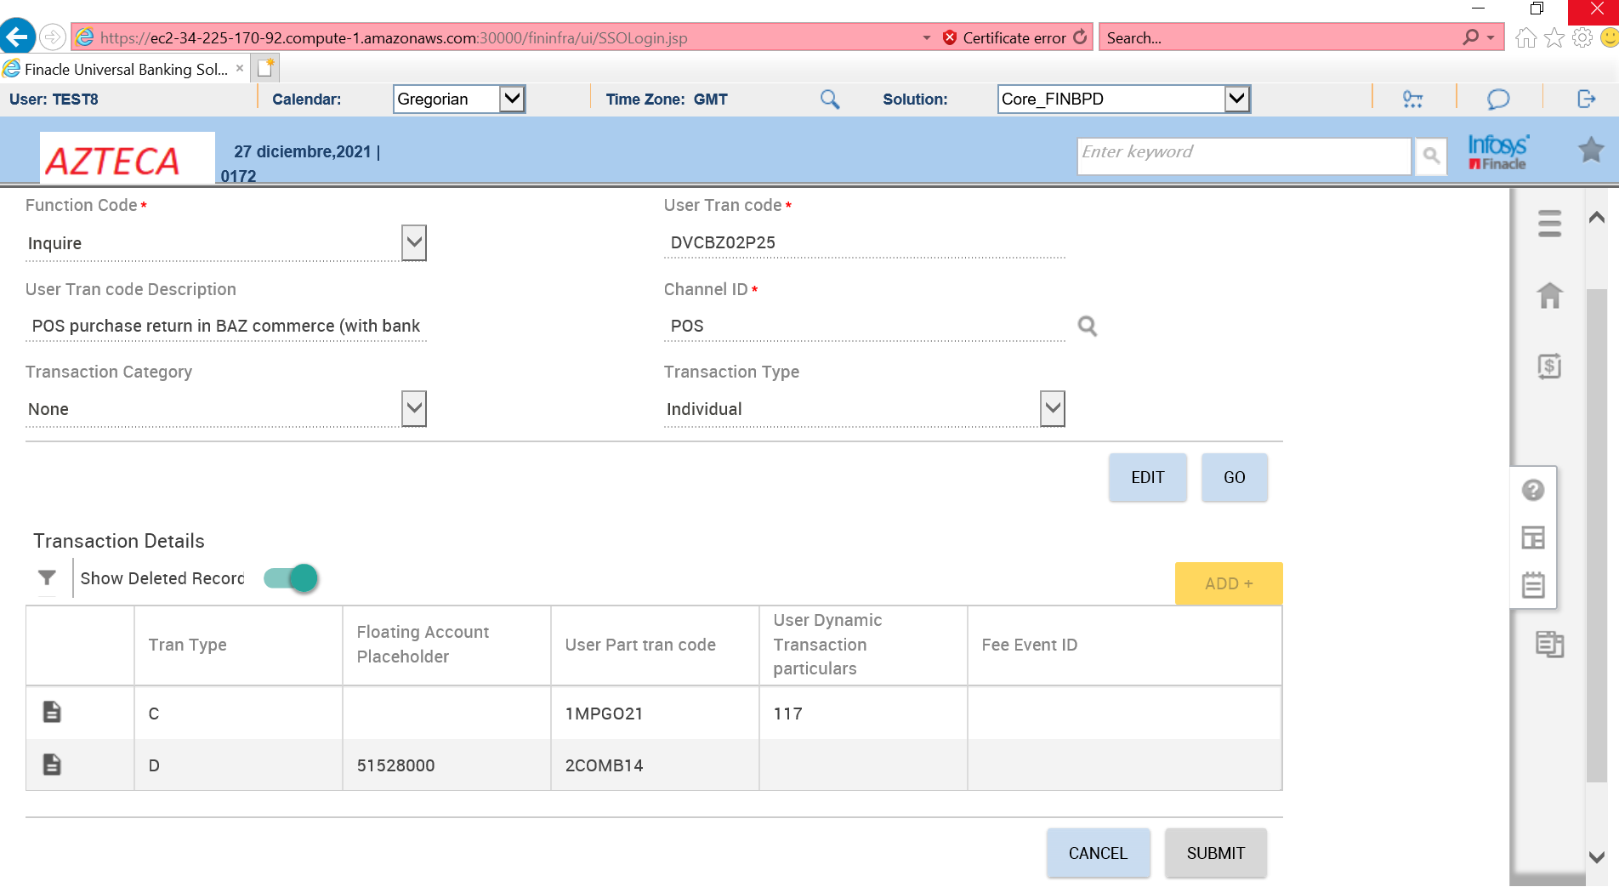

User Tran Code : DEVCBFPP25

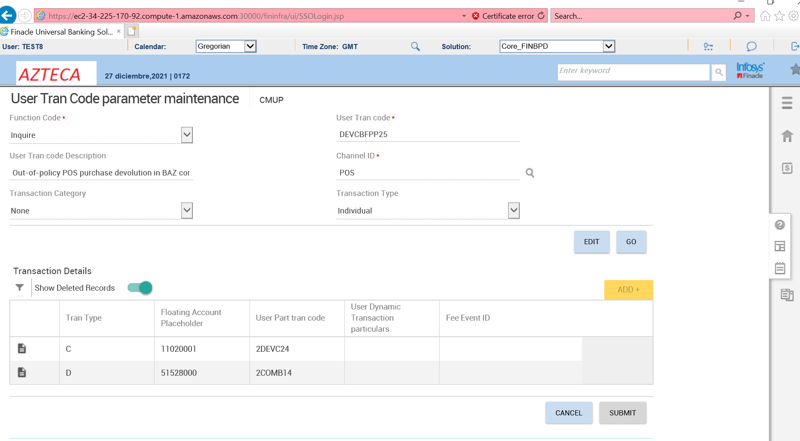

User Tran Code : PDCBZ02P25

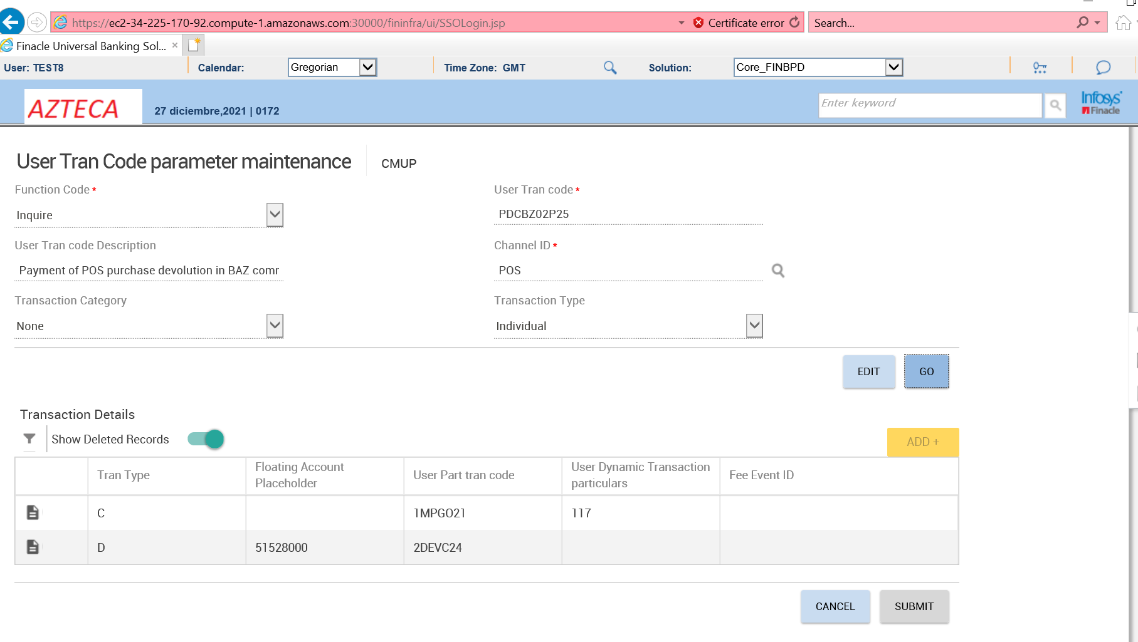

User Tran Code : DEVCO02P25

**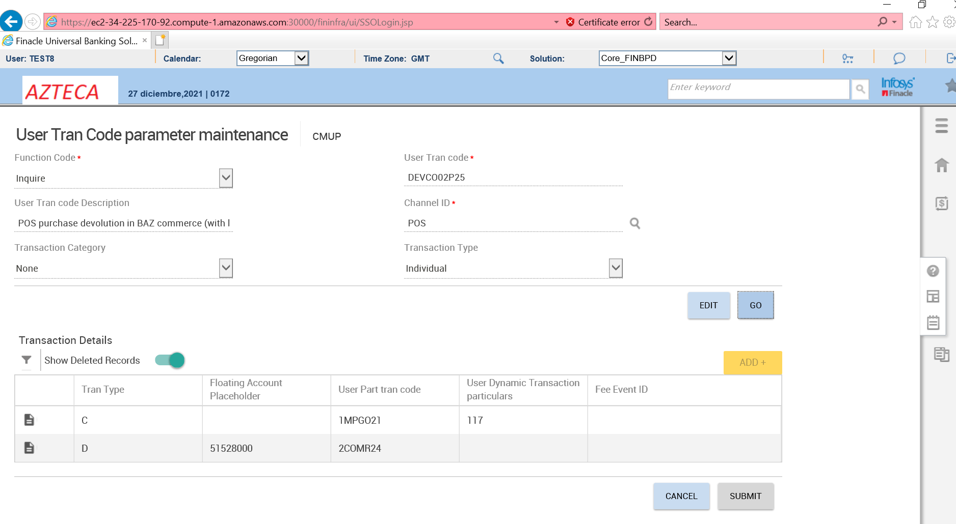**

User Tran Code : DEVCOFPP25

**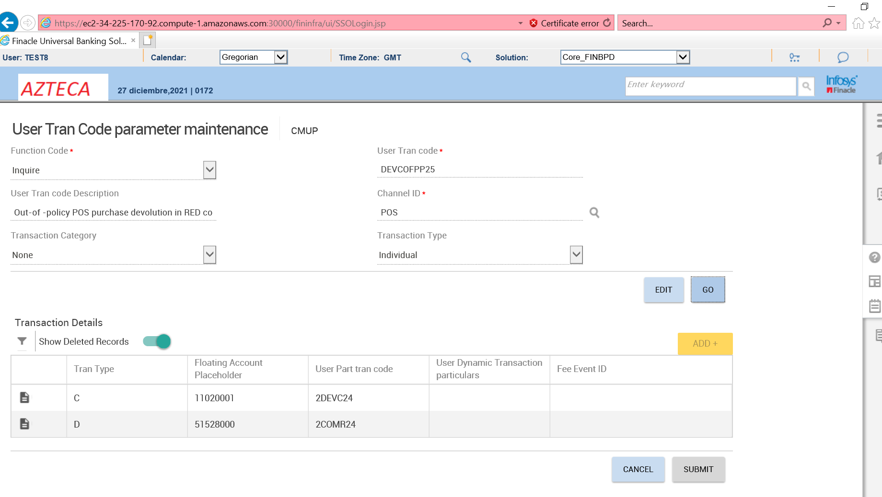**

User Tran Code : PDCOT02P25

**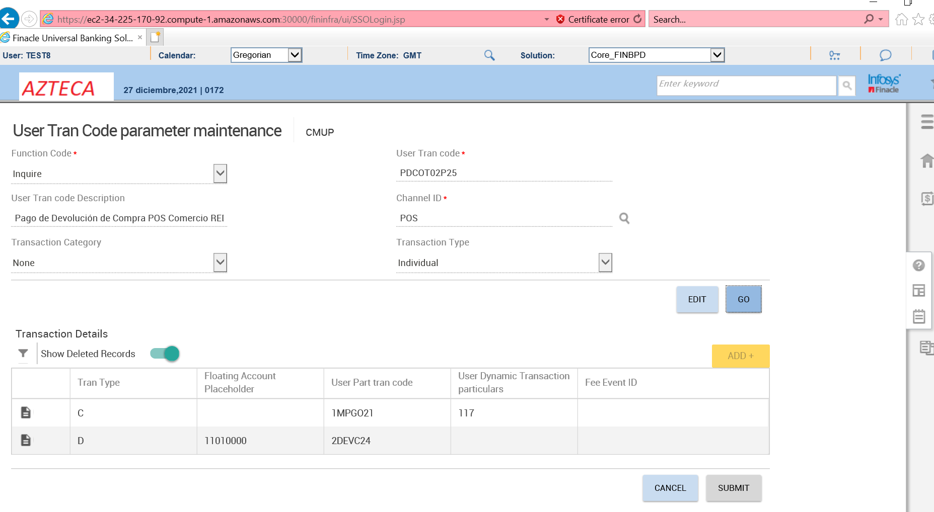**

User Tran Code : DCOEX01P25

**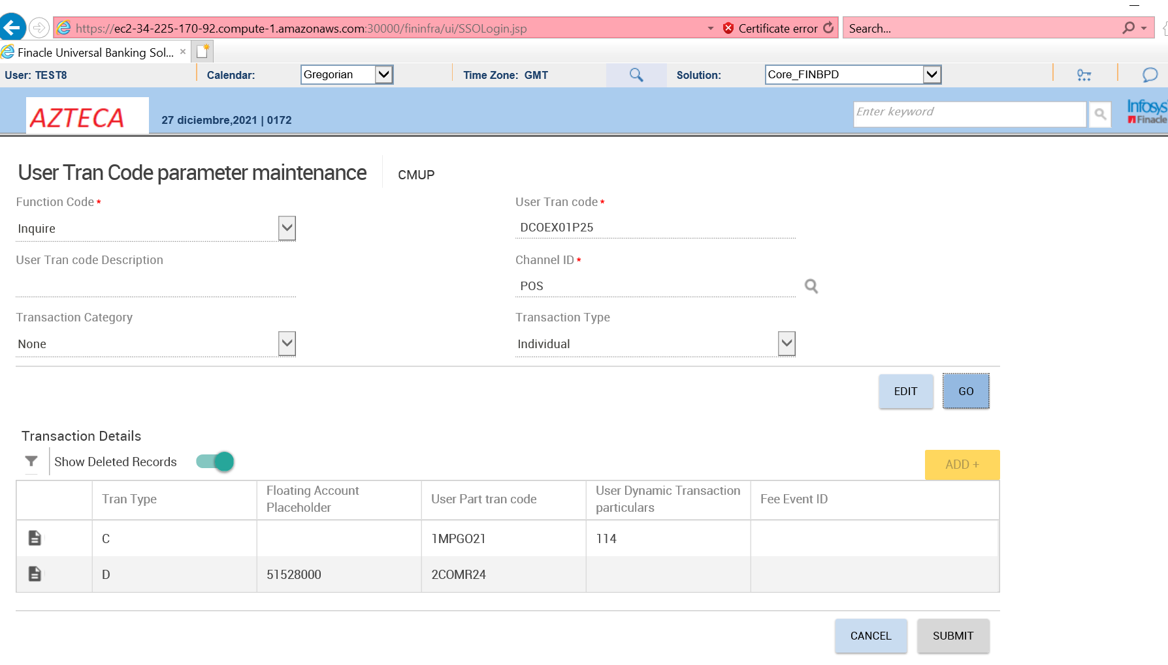**

User Tran Code : DEVCOEEP25

**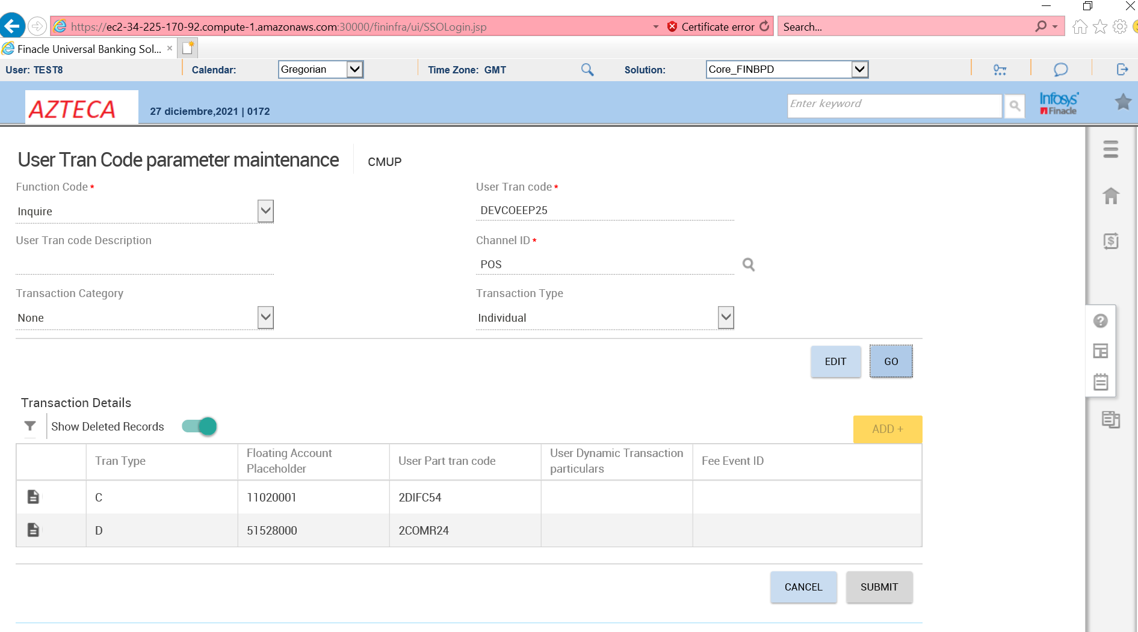**

User Tran Code : DEVCOEIP25

**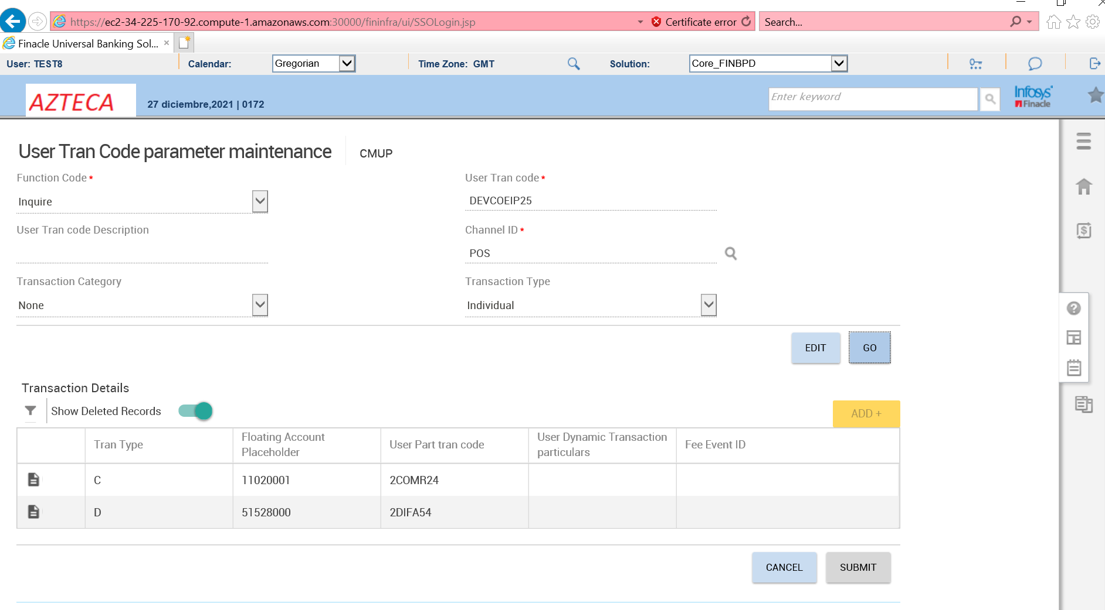**

User Tran Code : DCOMEXFP25

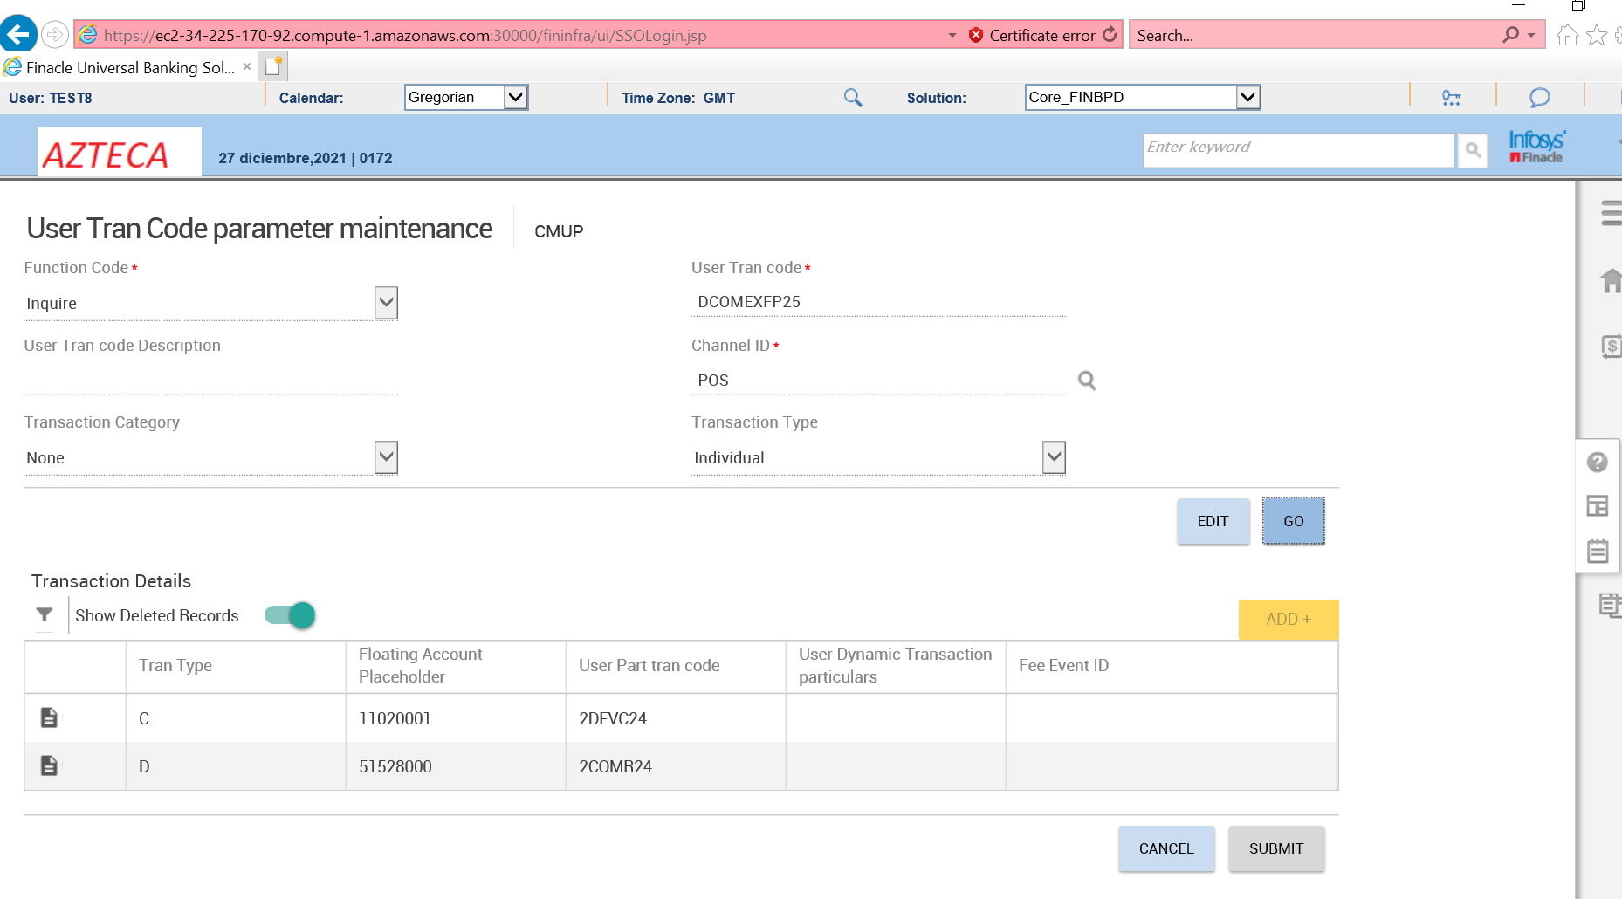

User Tran Code : PDCOEXFP25

**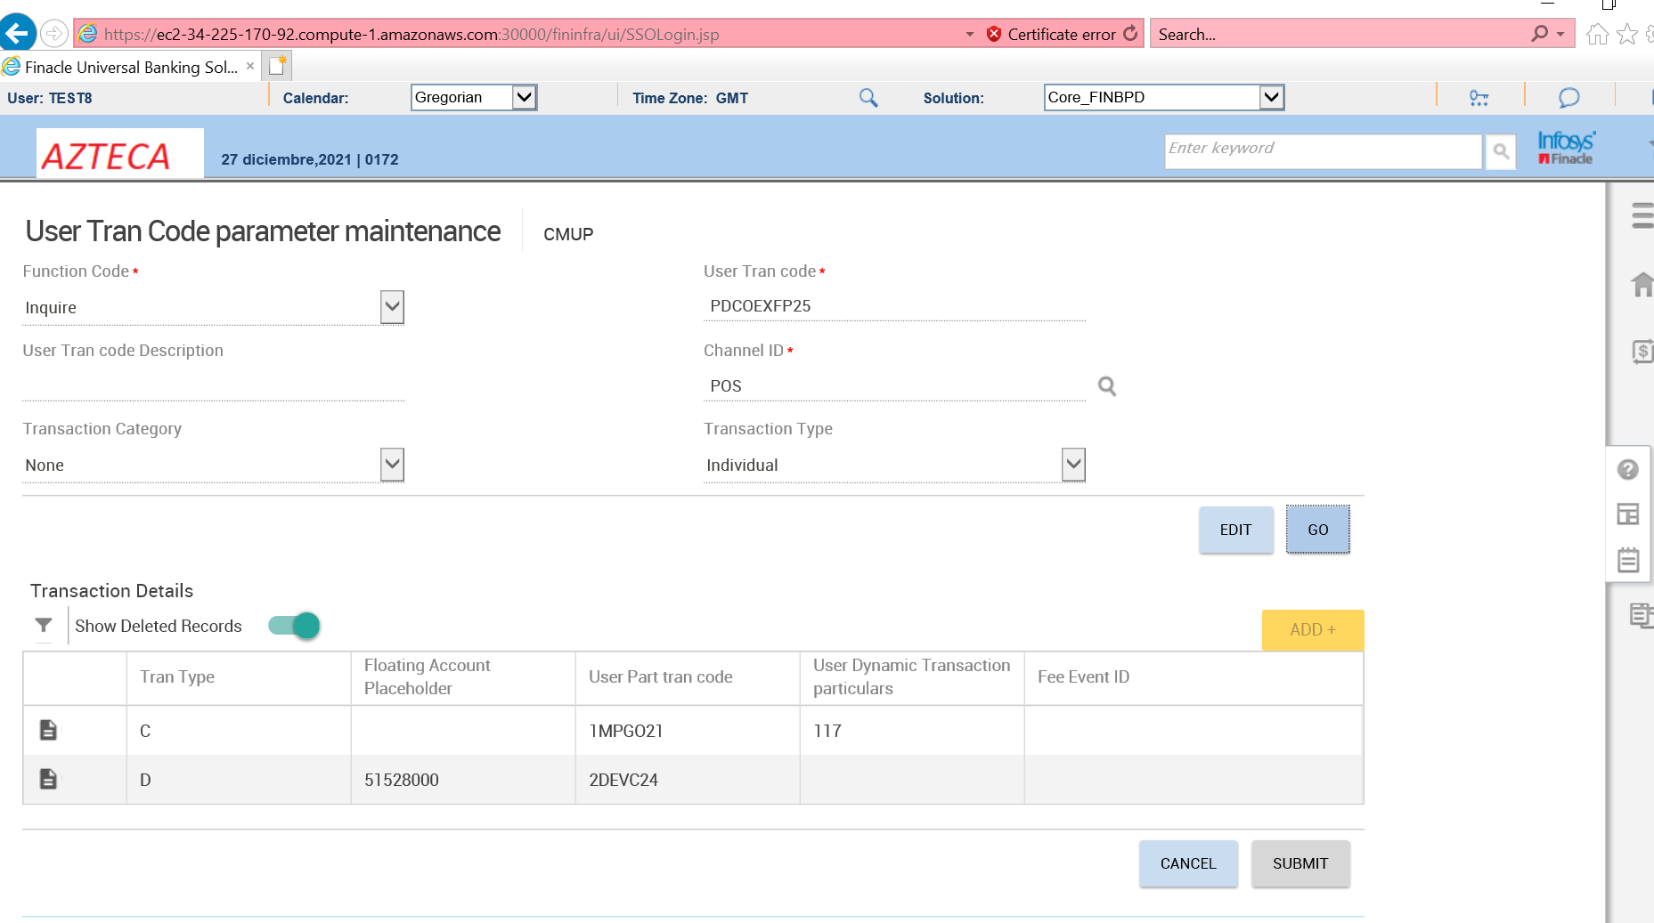**

Incident transaction

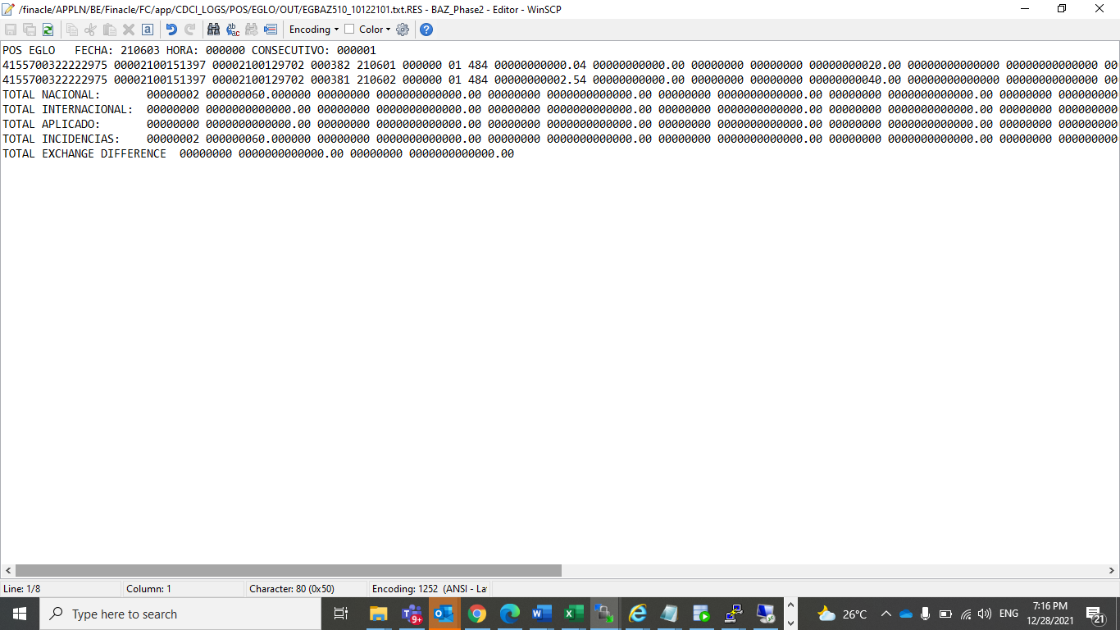

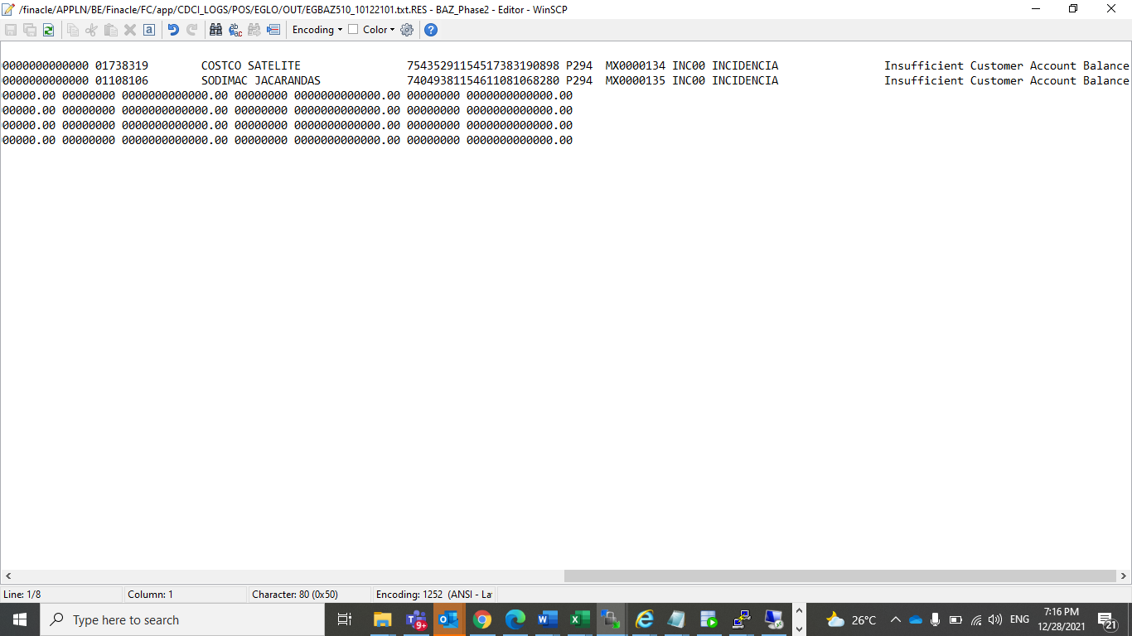

Aplicado

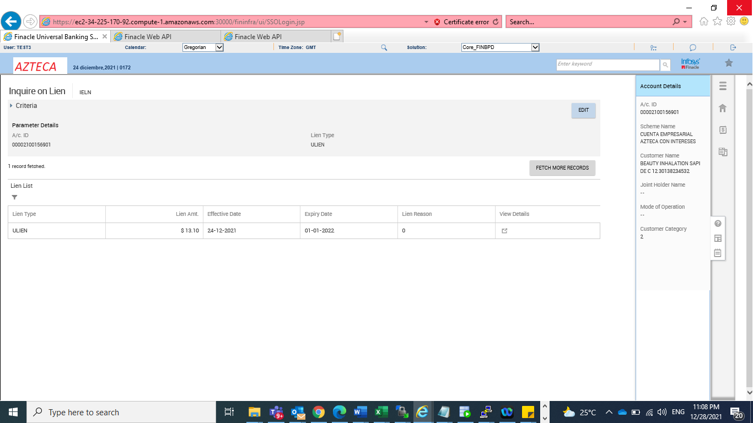

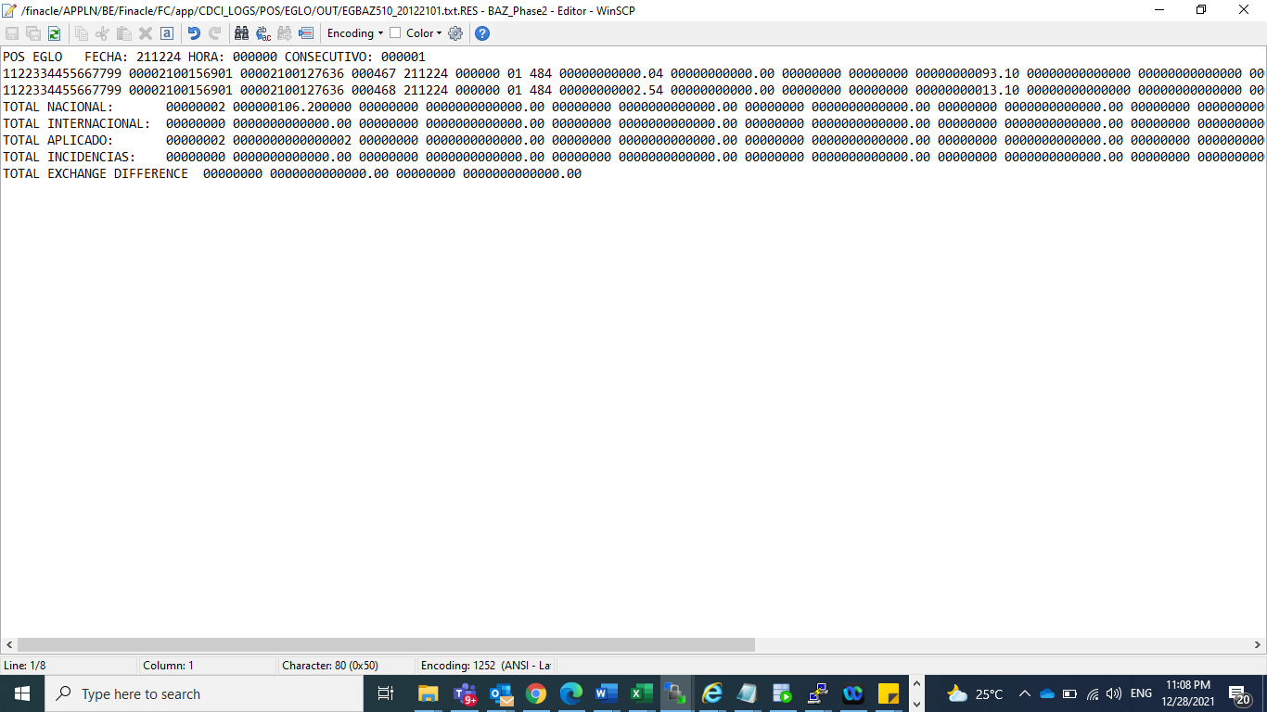

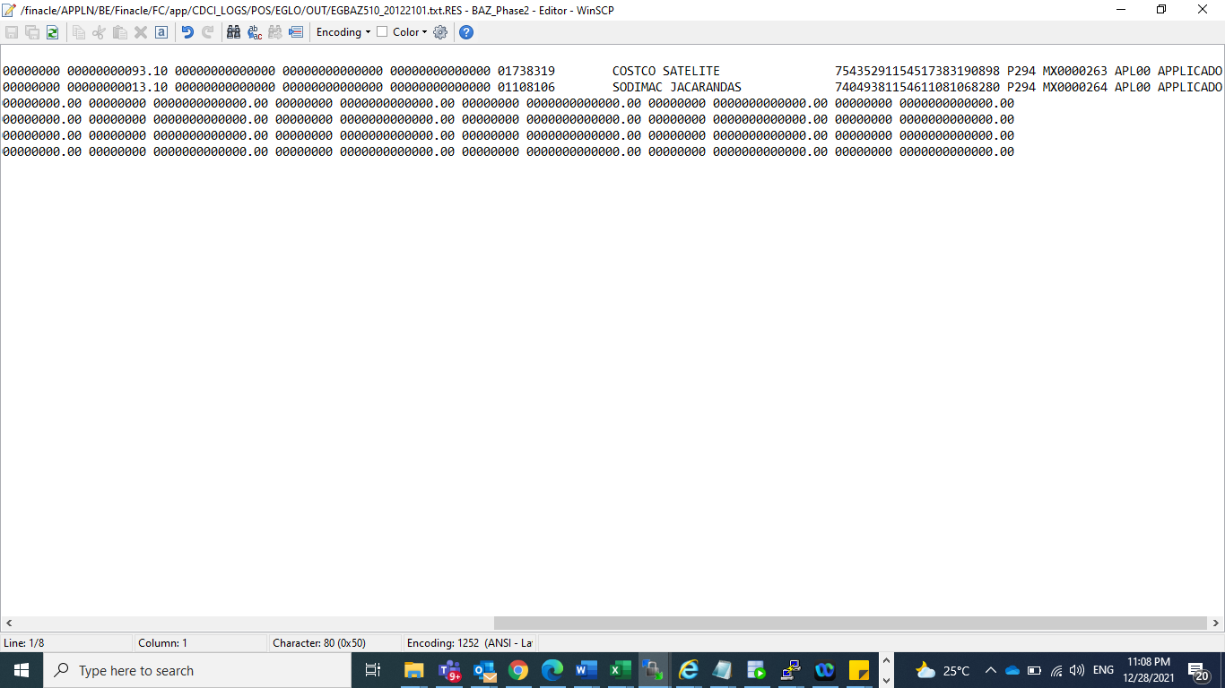

Txn n lien inquiry

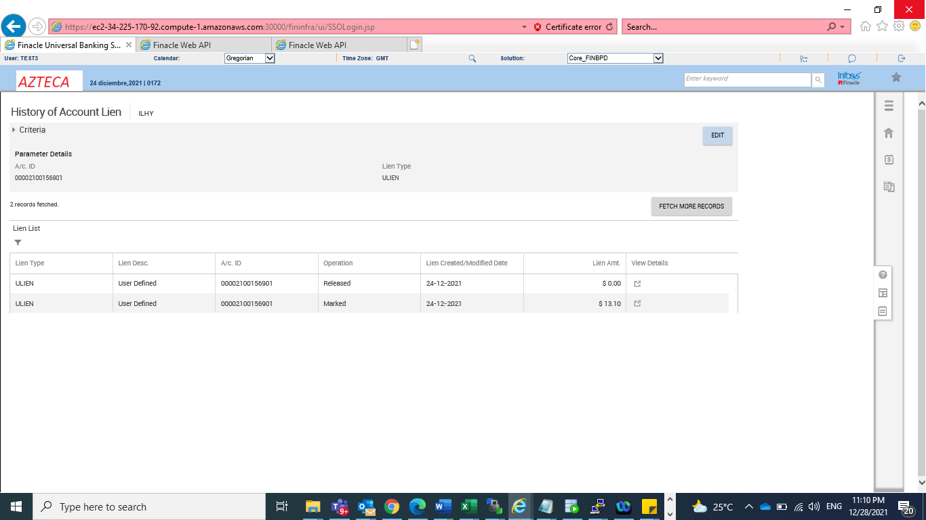

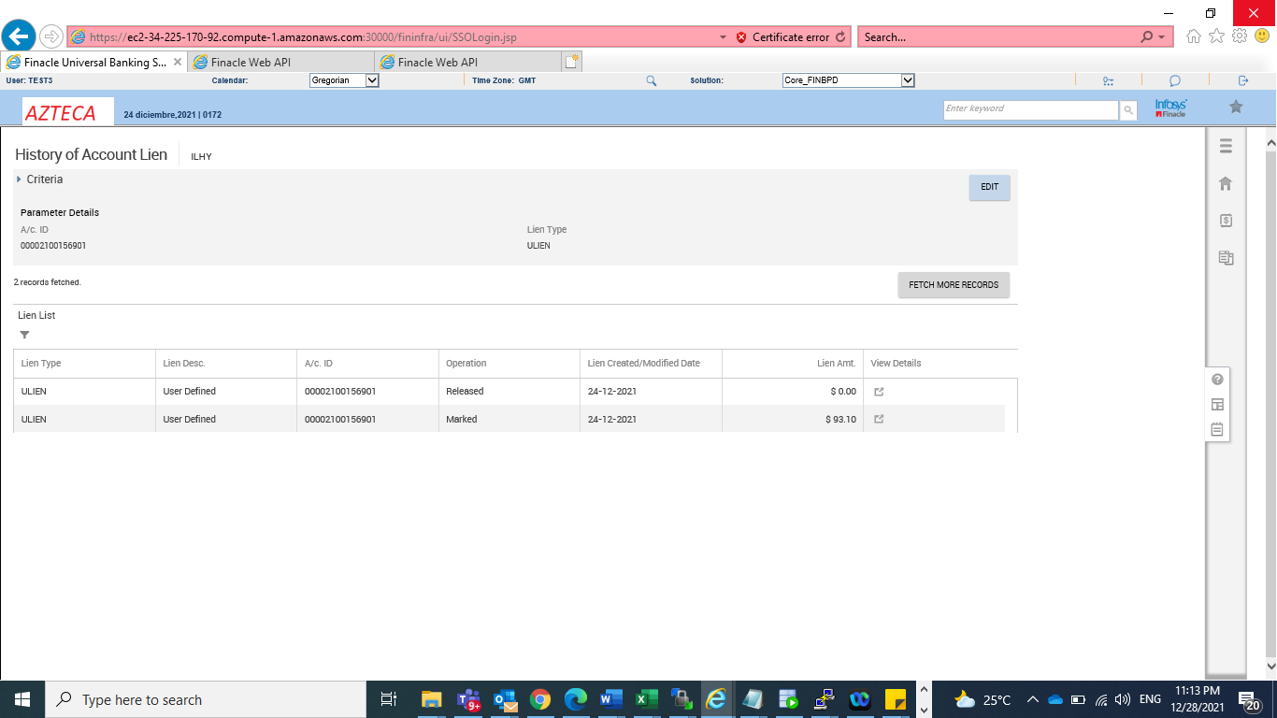

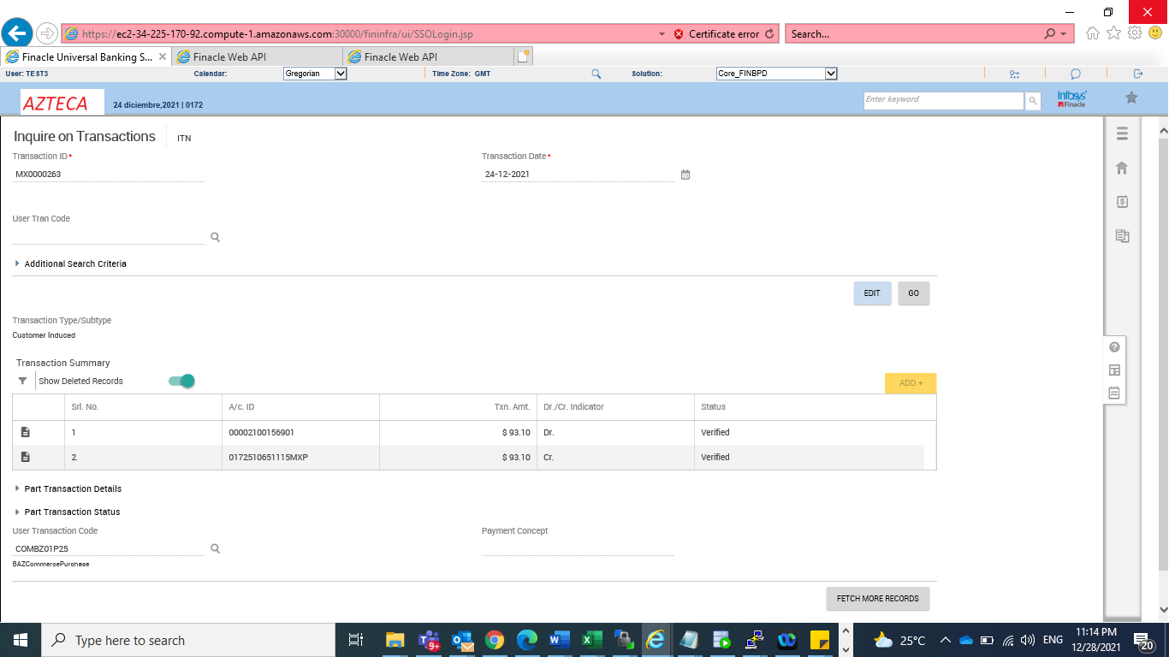

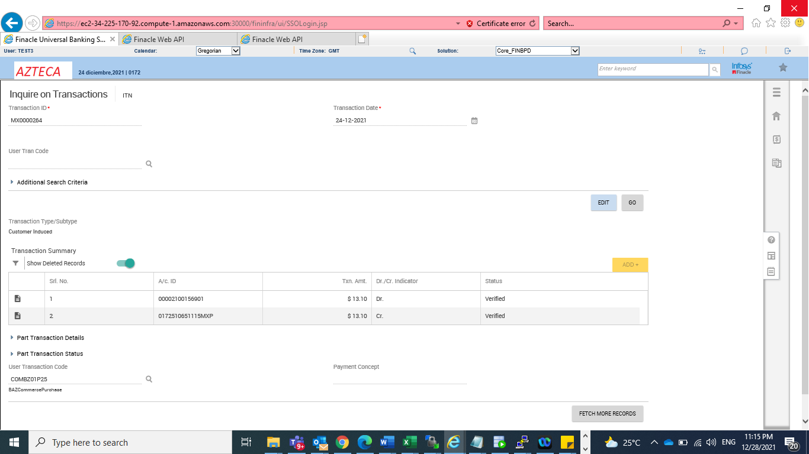

Coverage txn

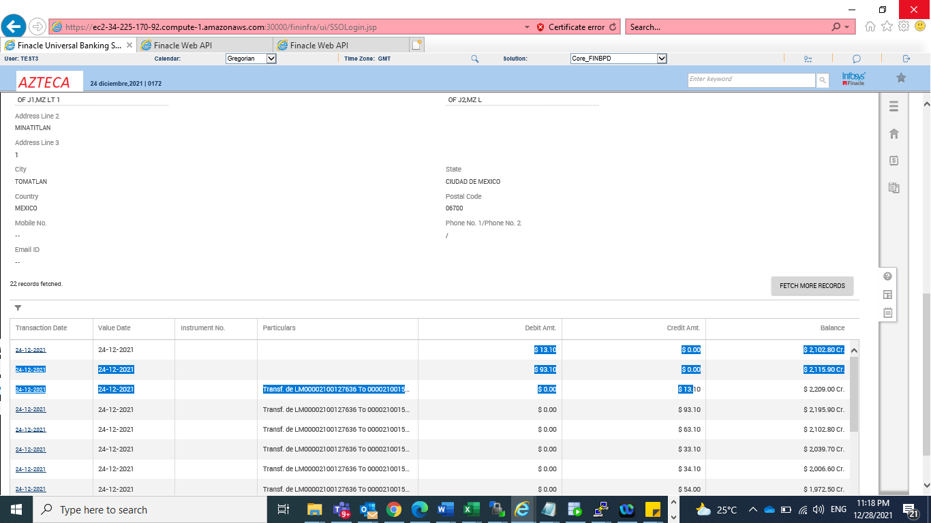

Offline txn, Auth id mismatch, insufficient balance,excess short txn value

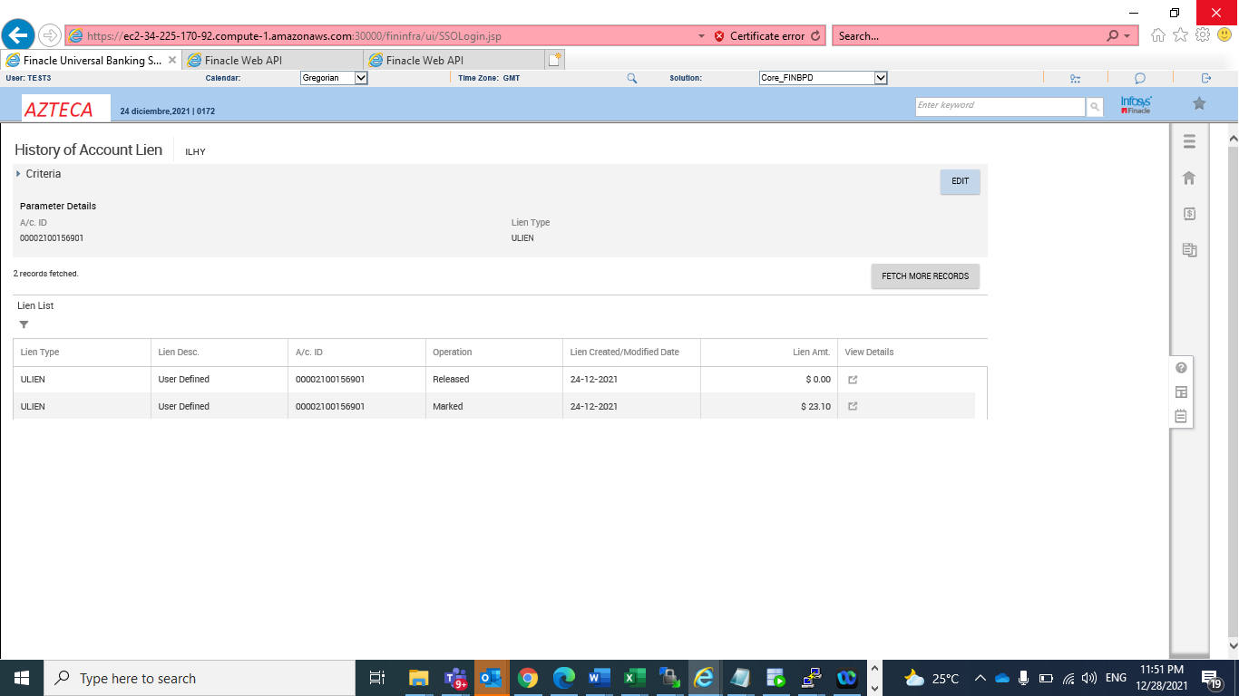

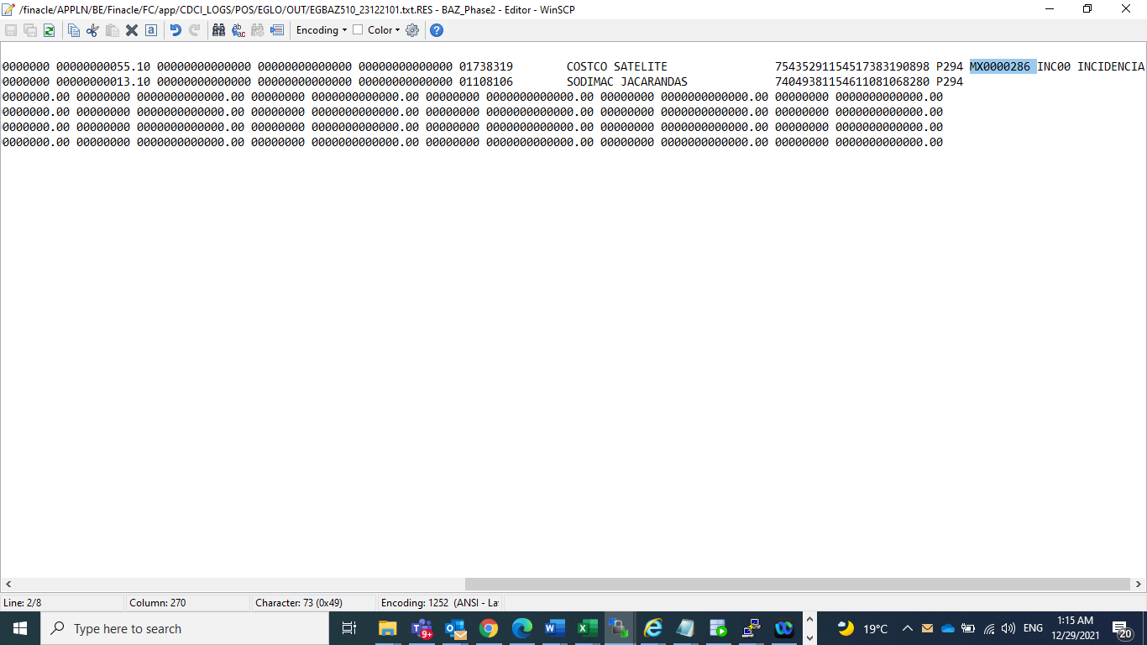

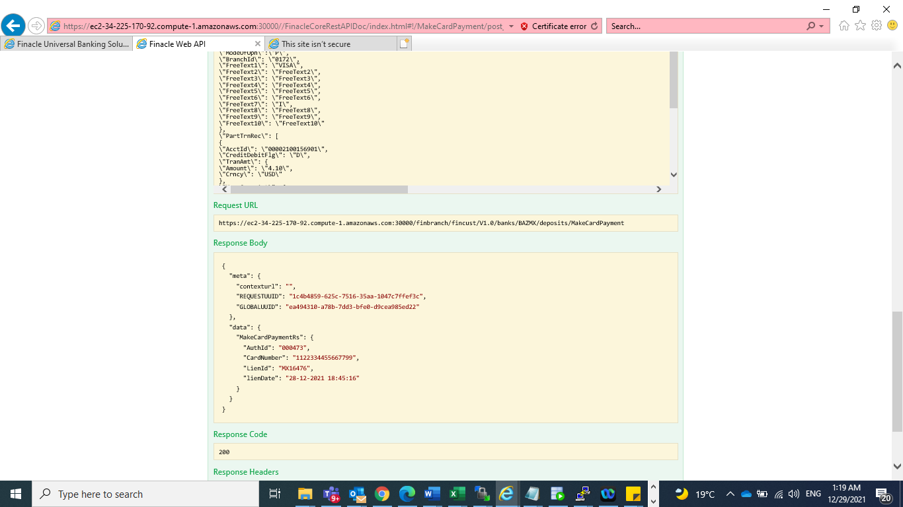

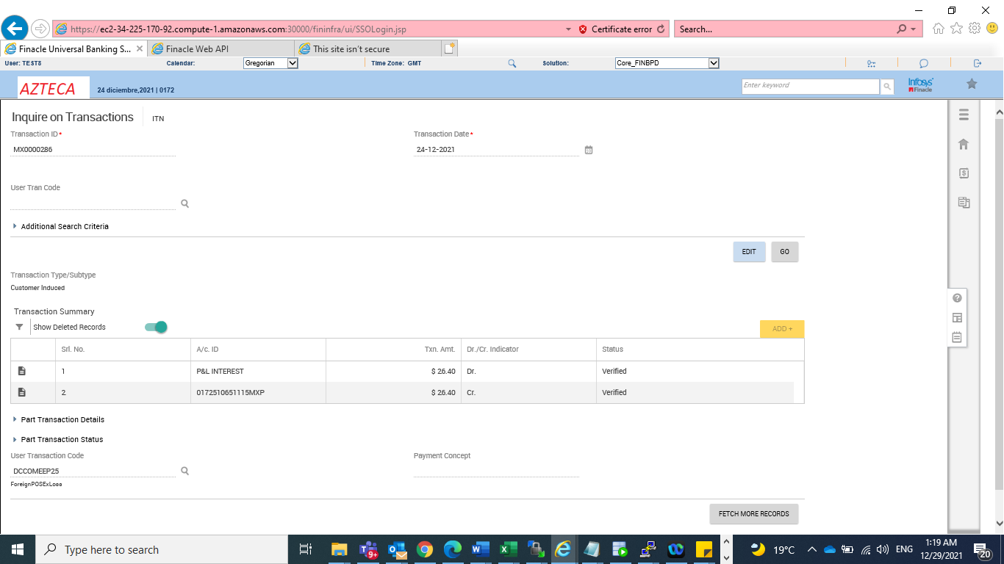

Offline txn

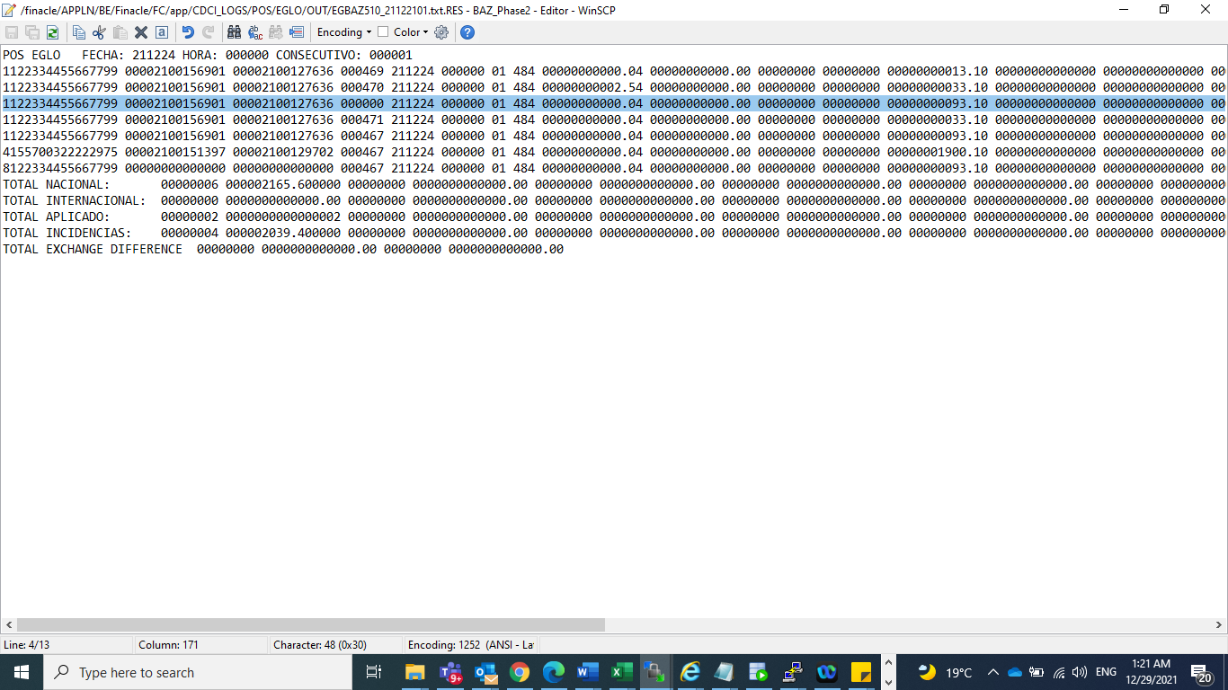

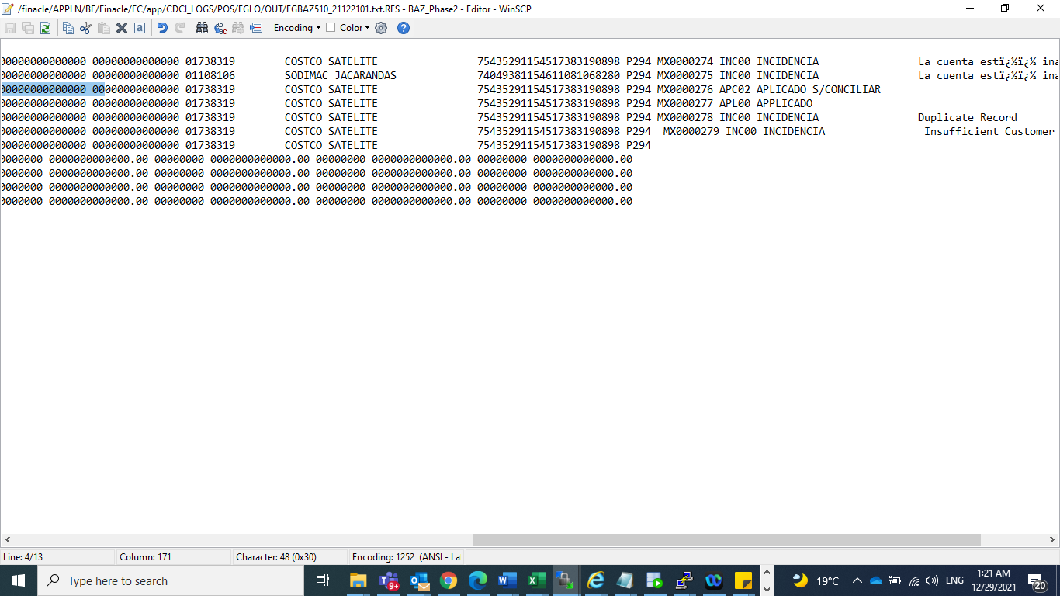

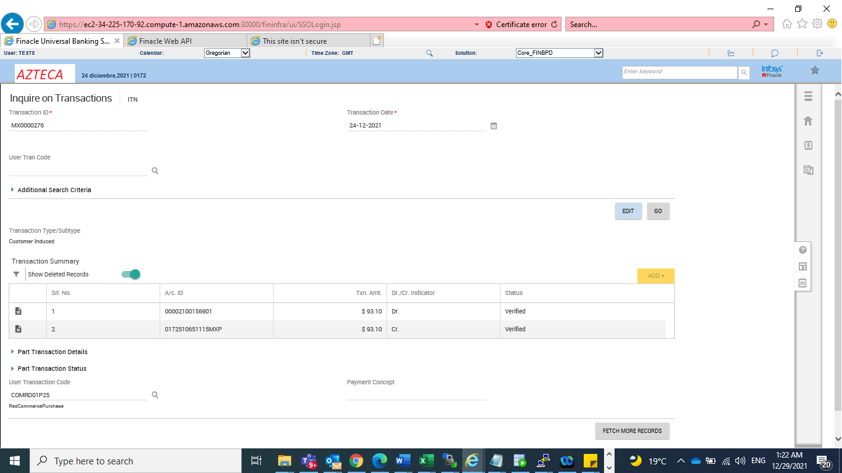

Insuficent funds

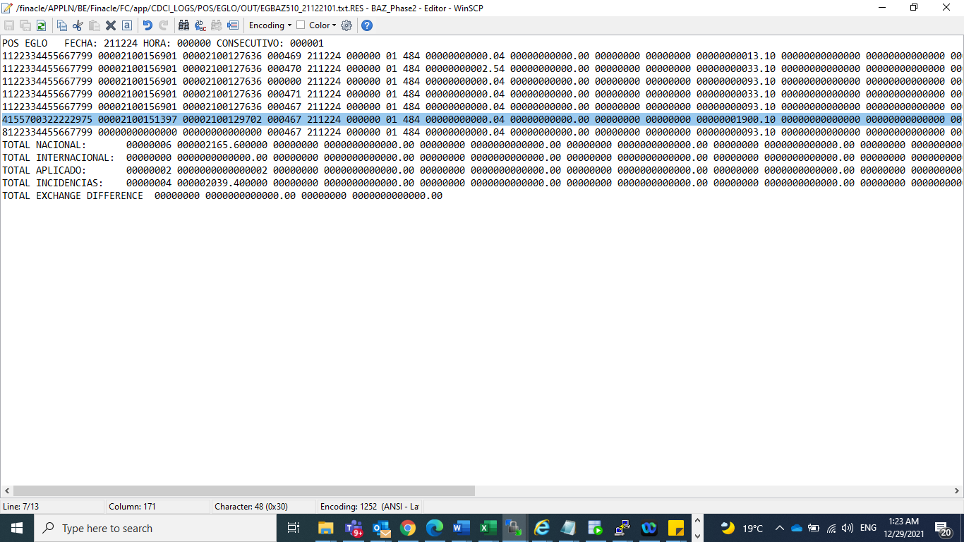

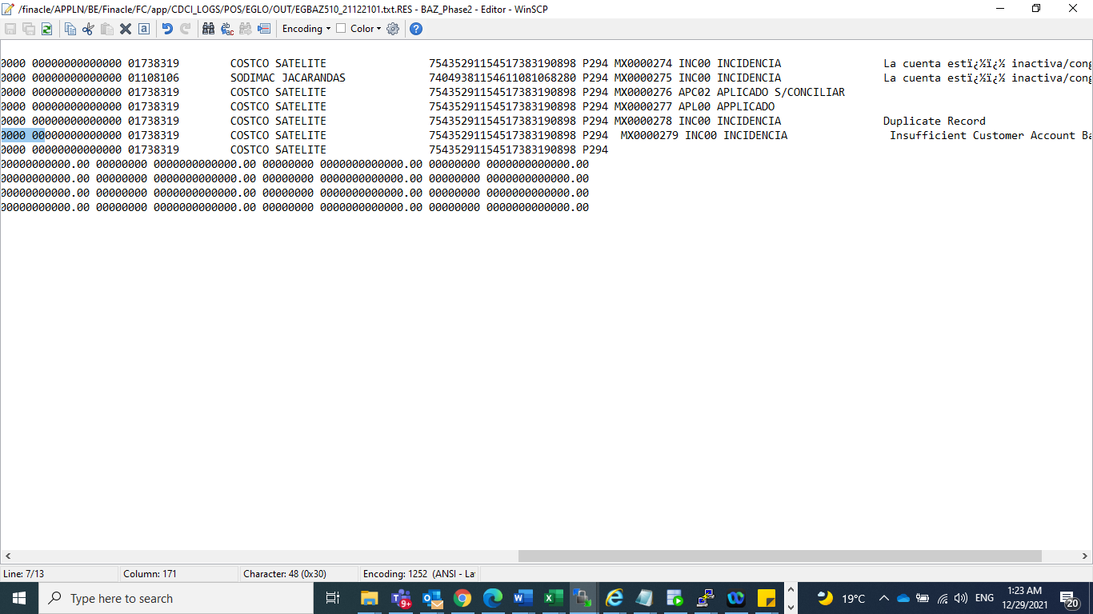

Prosa file processing

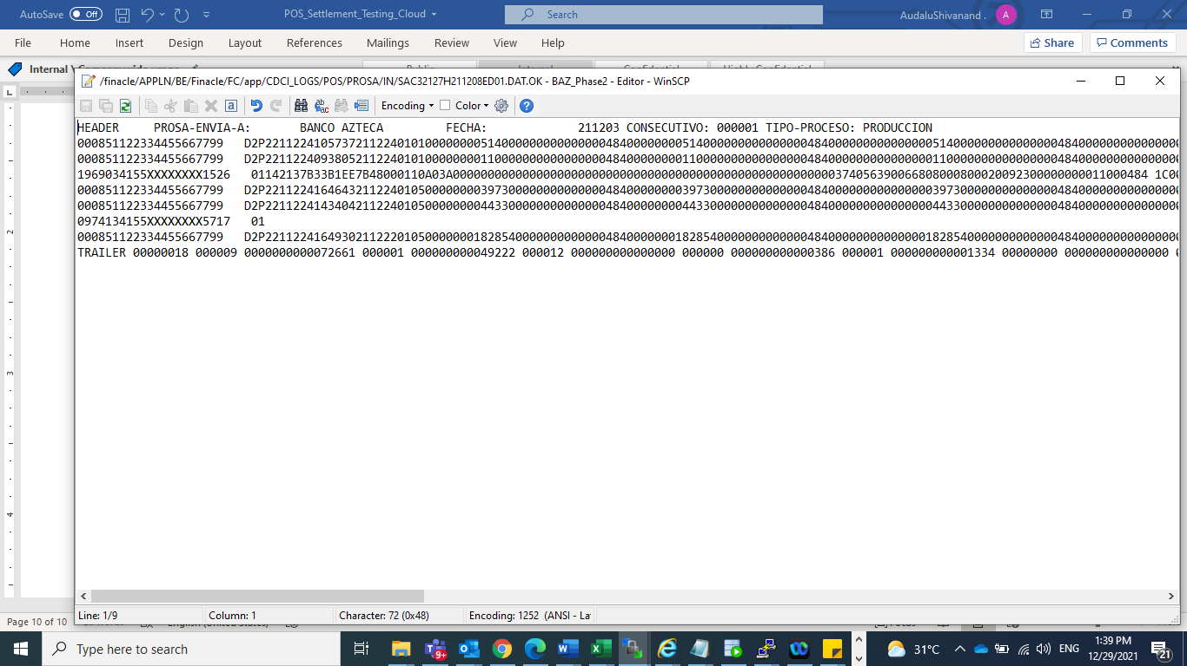

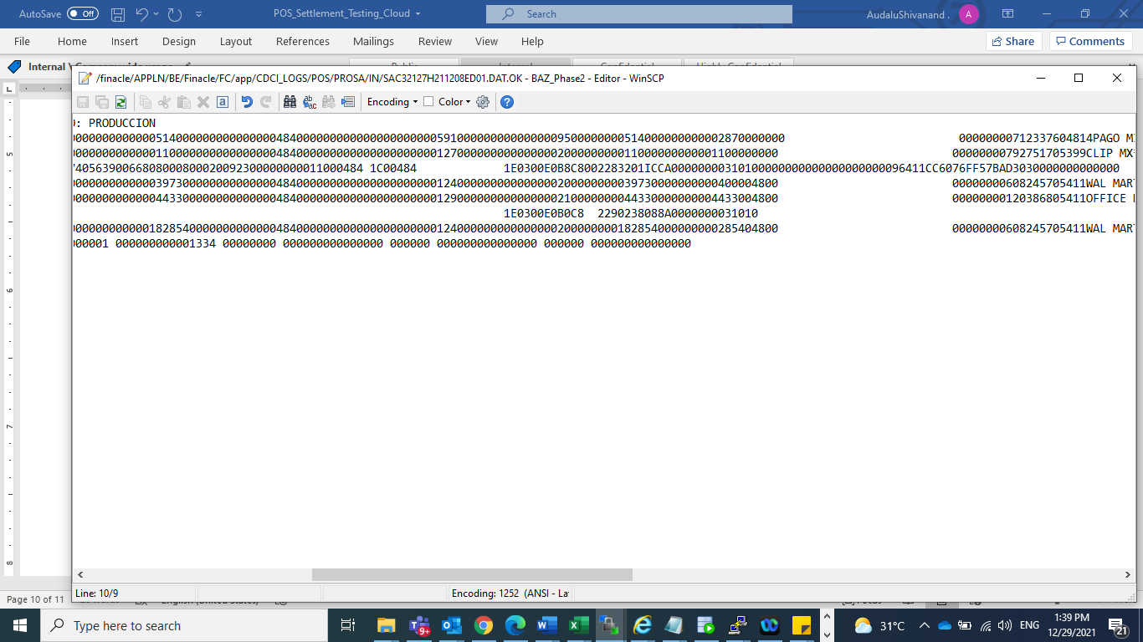

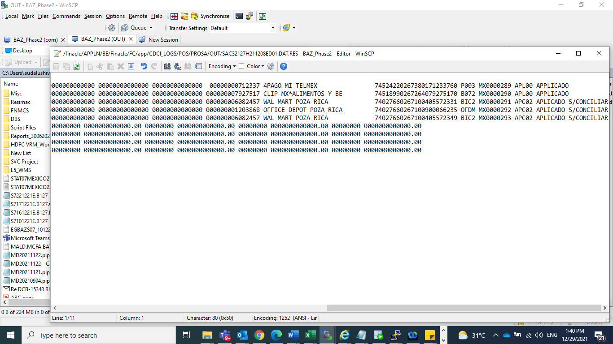

ADQ FILE PROCESSING

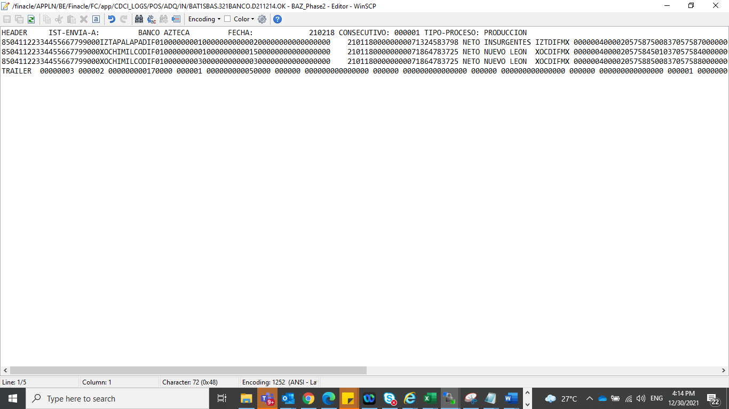

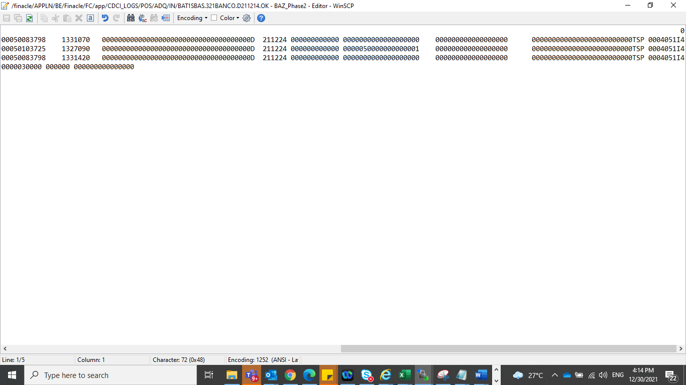

Response file

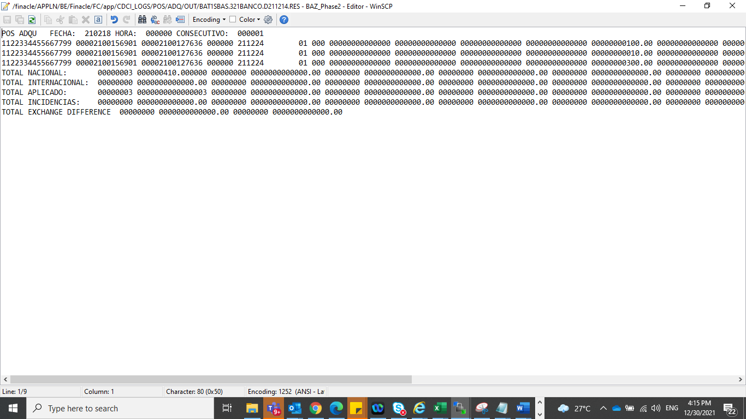

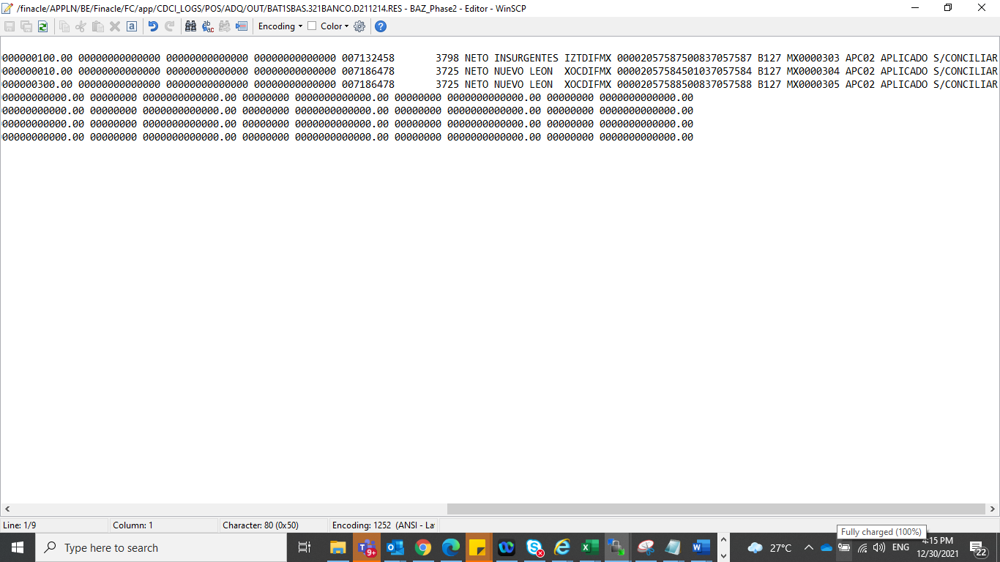

POS settlement-Devolucion-ADQ file

POS\_settlement.com P

Purchase Full devolucion-Applicado

Purchase Partial Devolucion-Applicado

Inactive account-Incident ac

Offline txn-Applicado-

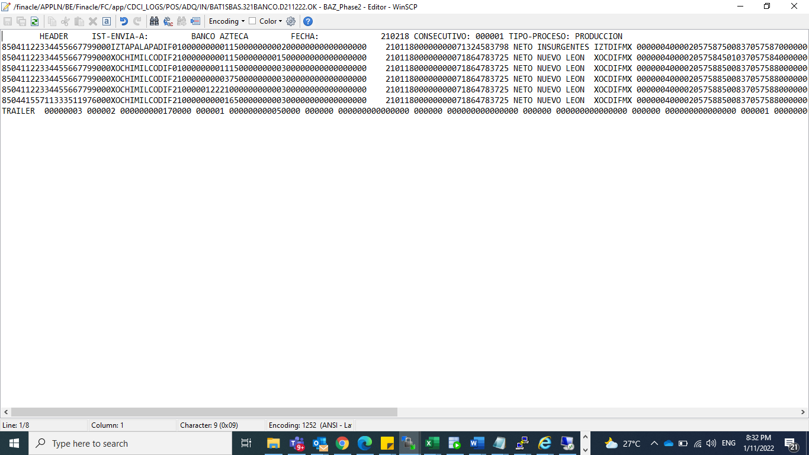

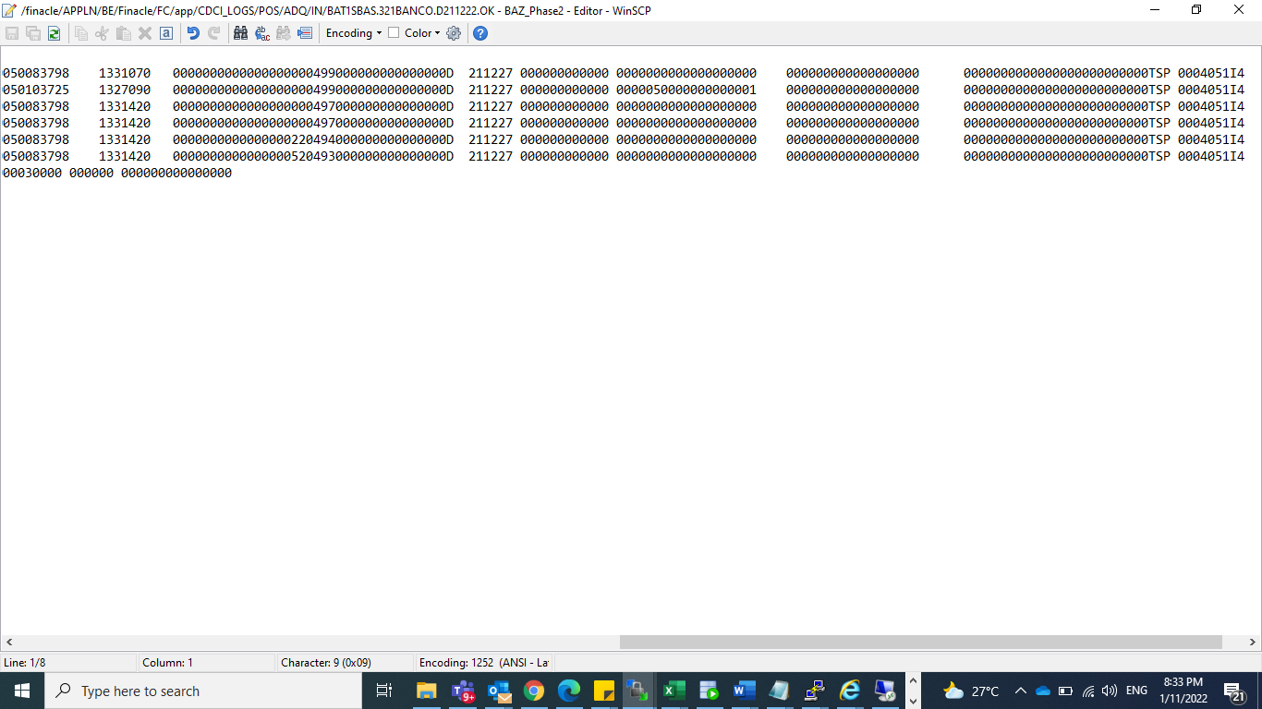

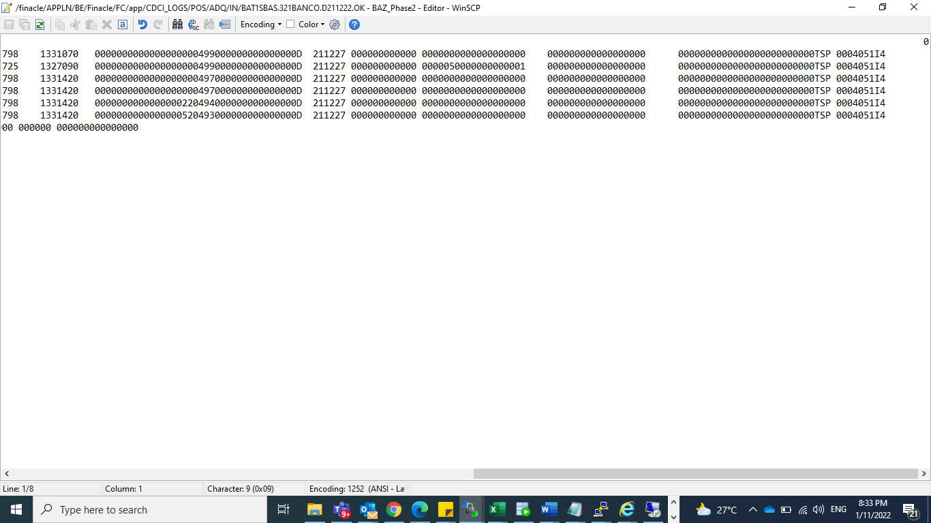

Output File

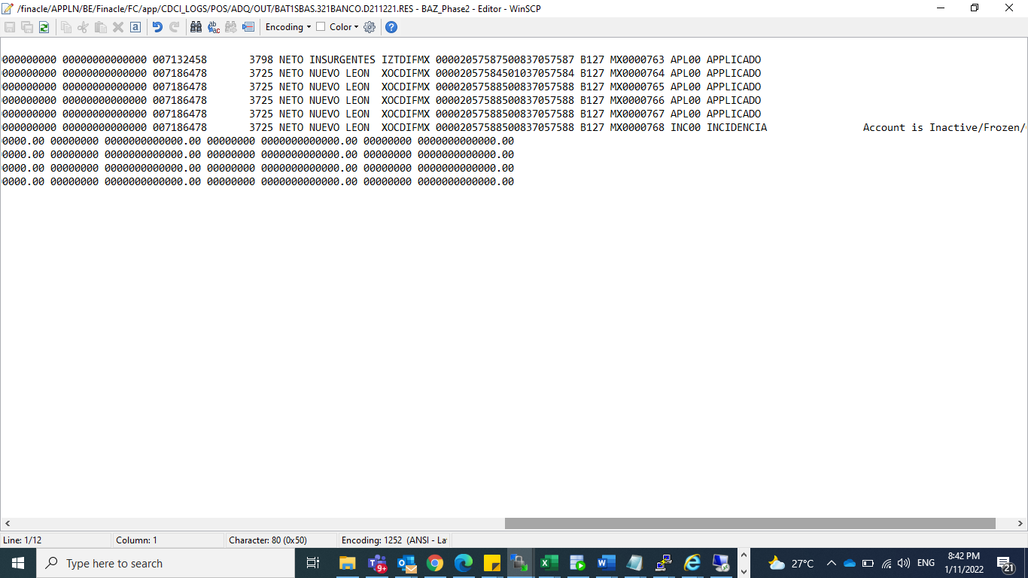

Tran codes

Analysis account

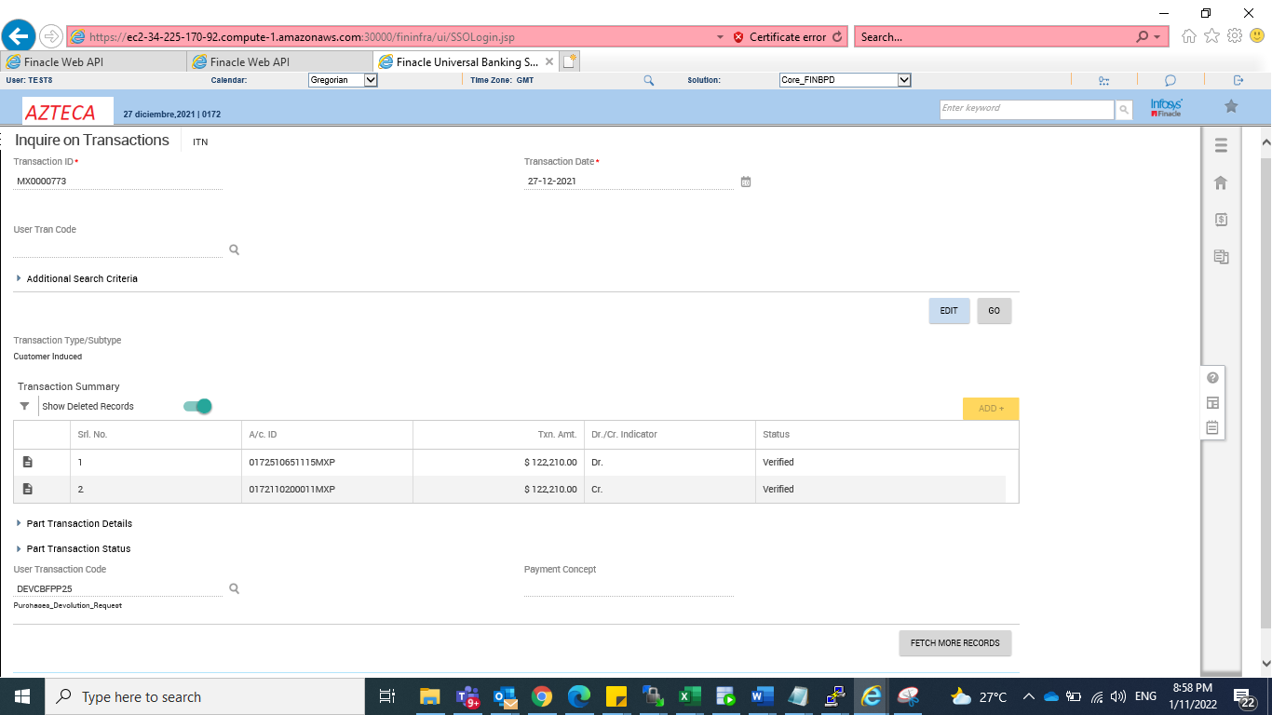

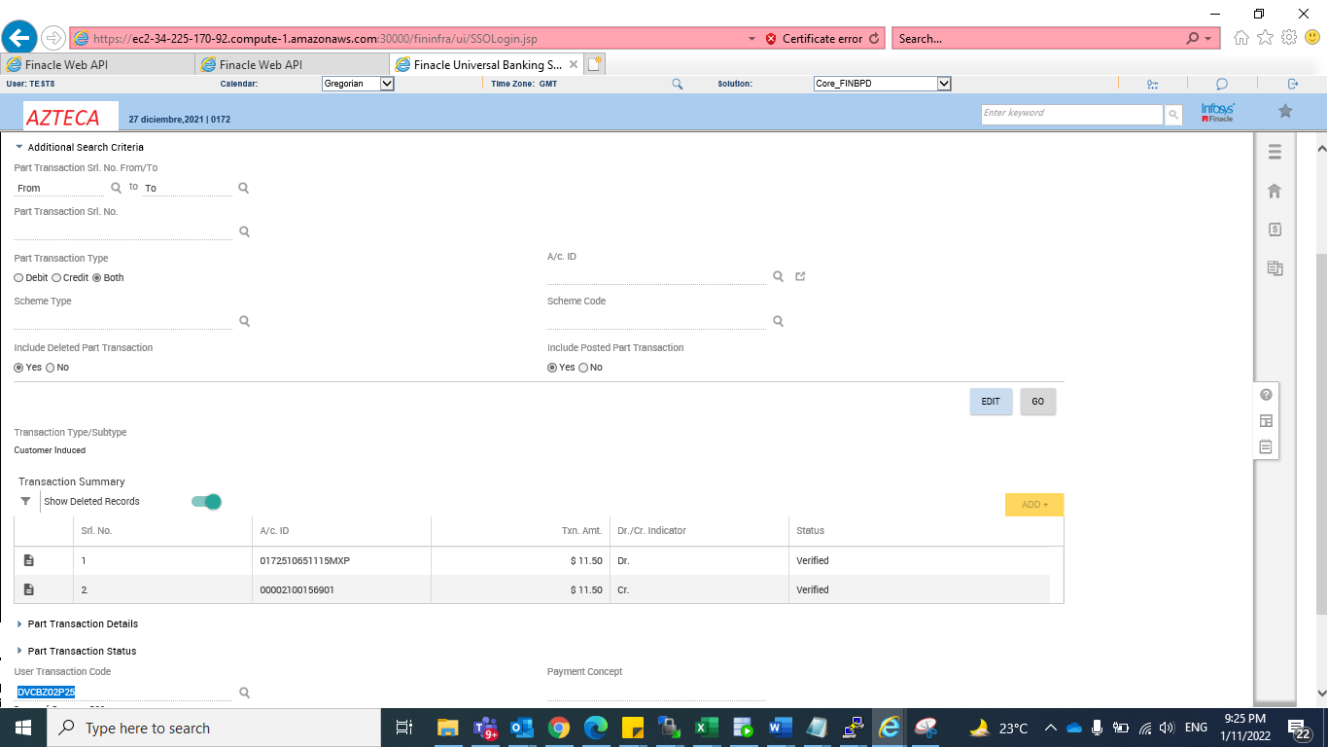

POS international txn

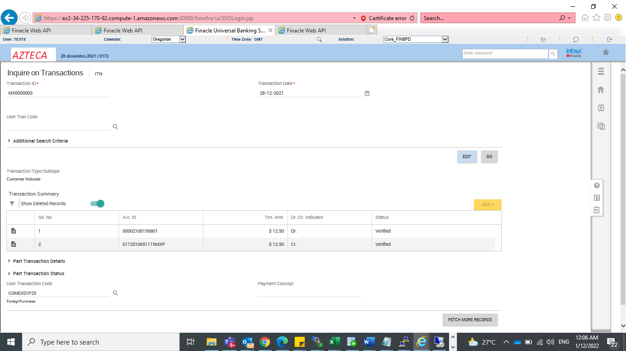

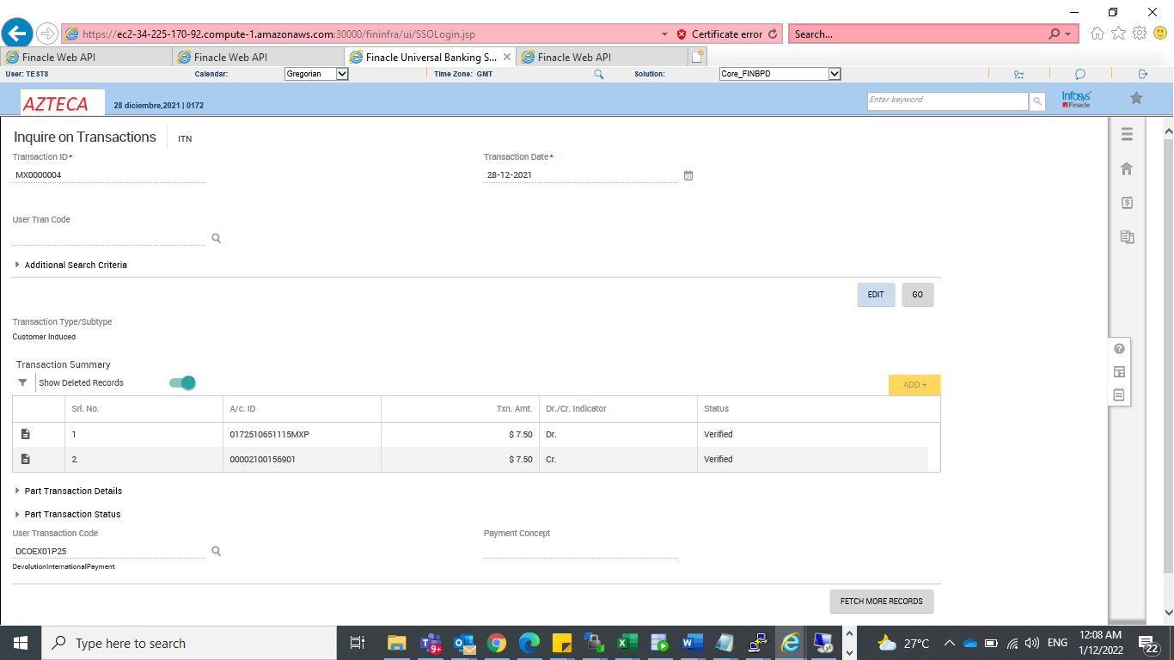

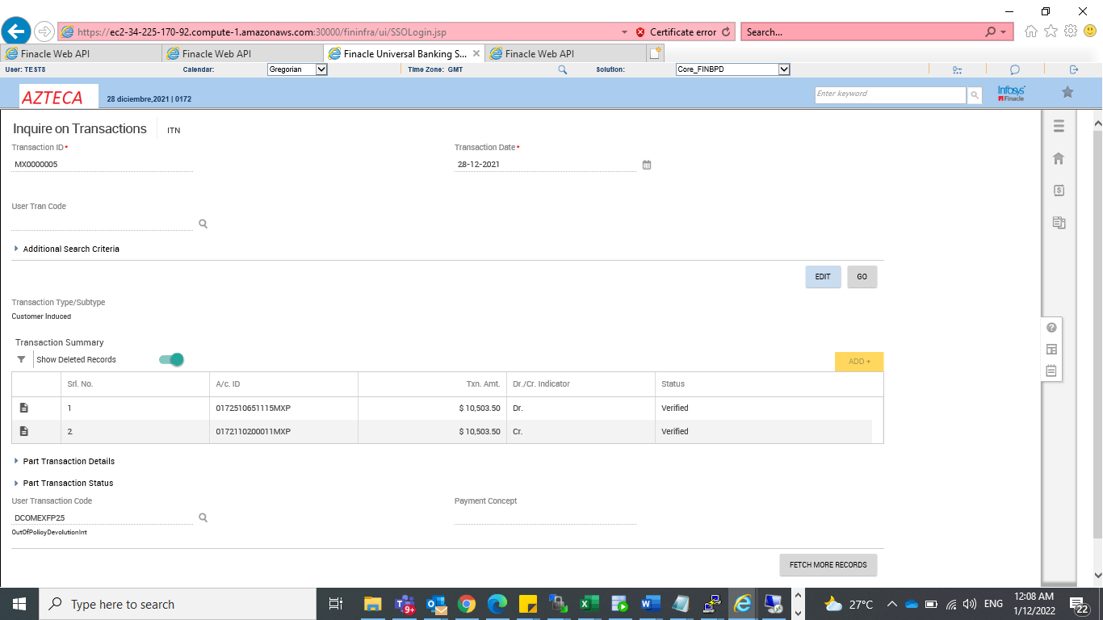

Lien inqury

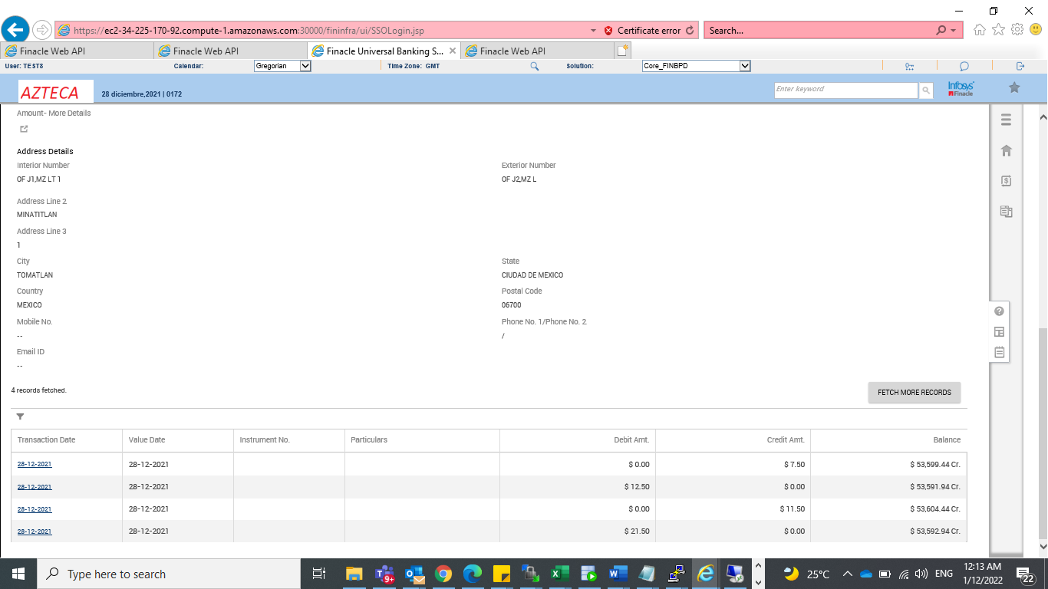

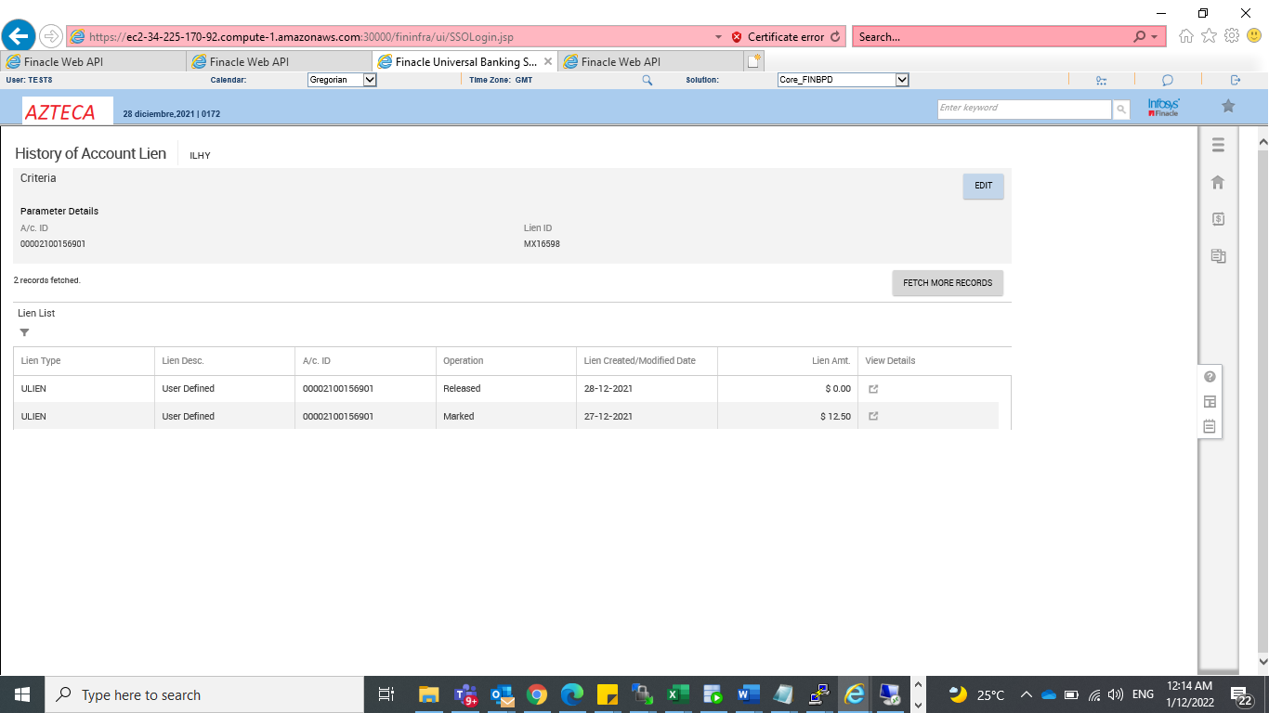

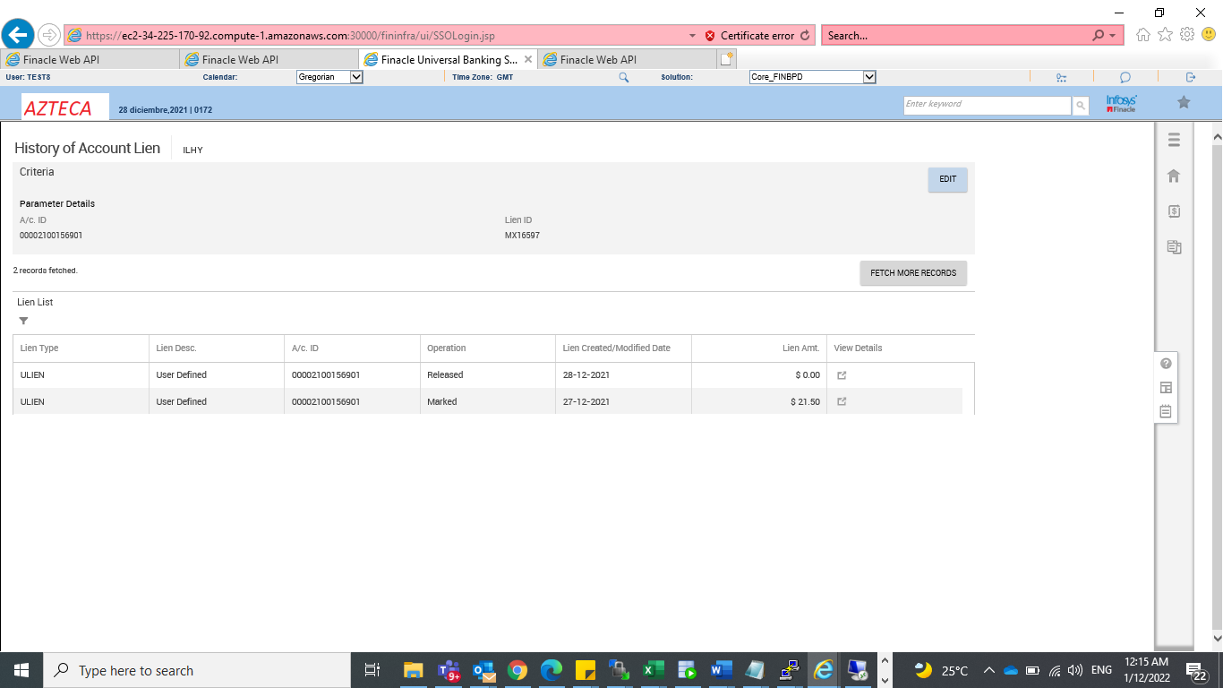

Red ATM

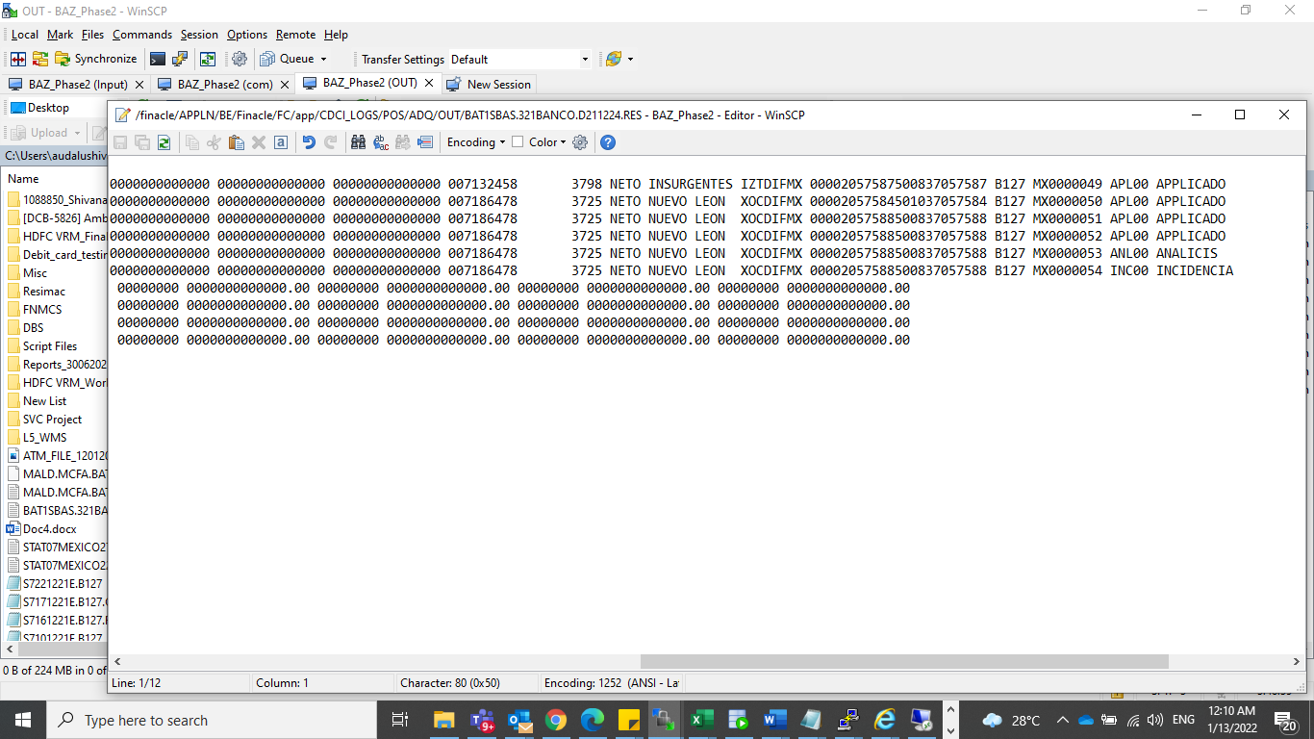

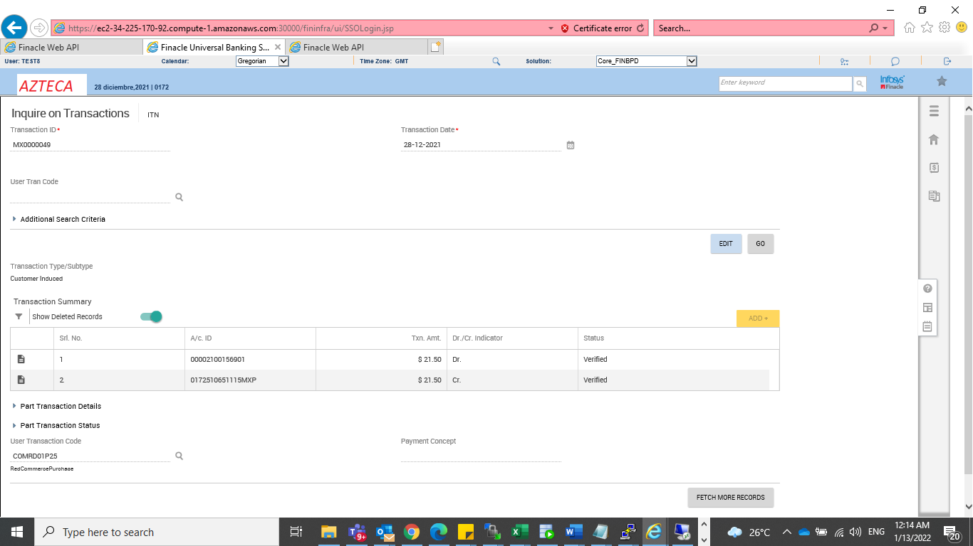

Red POS devolucion

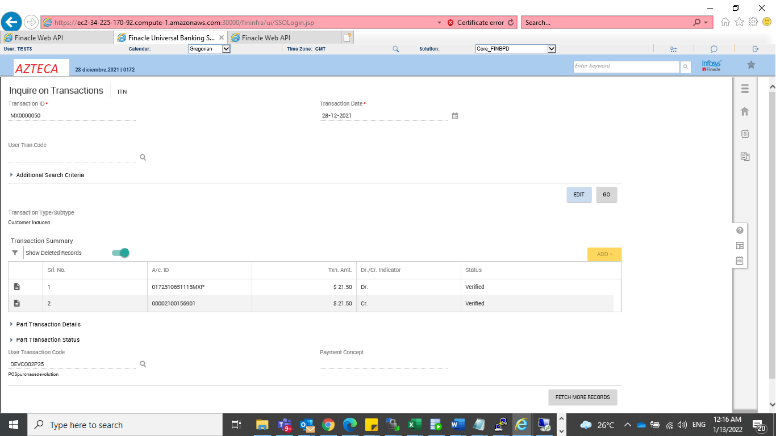

Out of policy

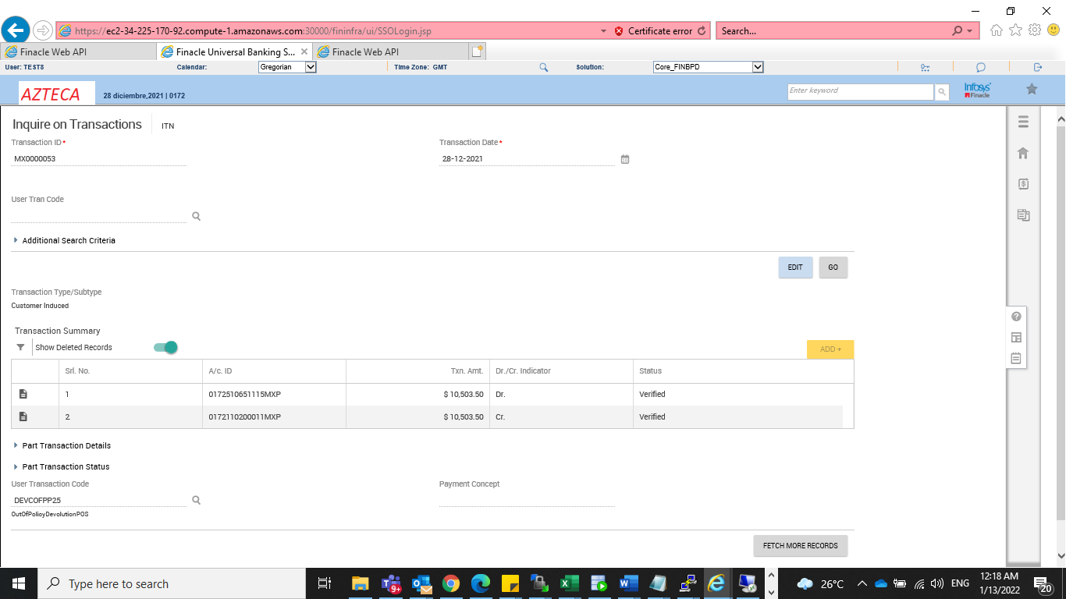

Duplicate devolucion

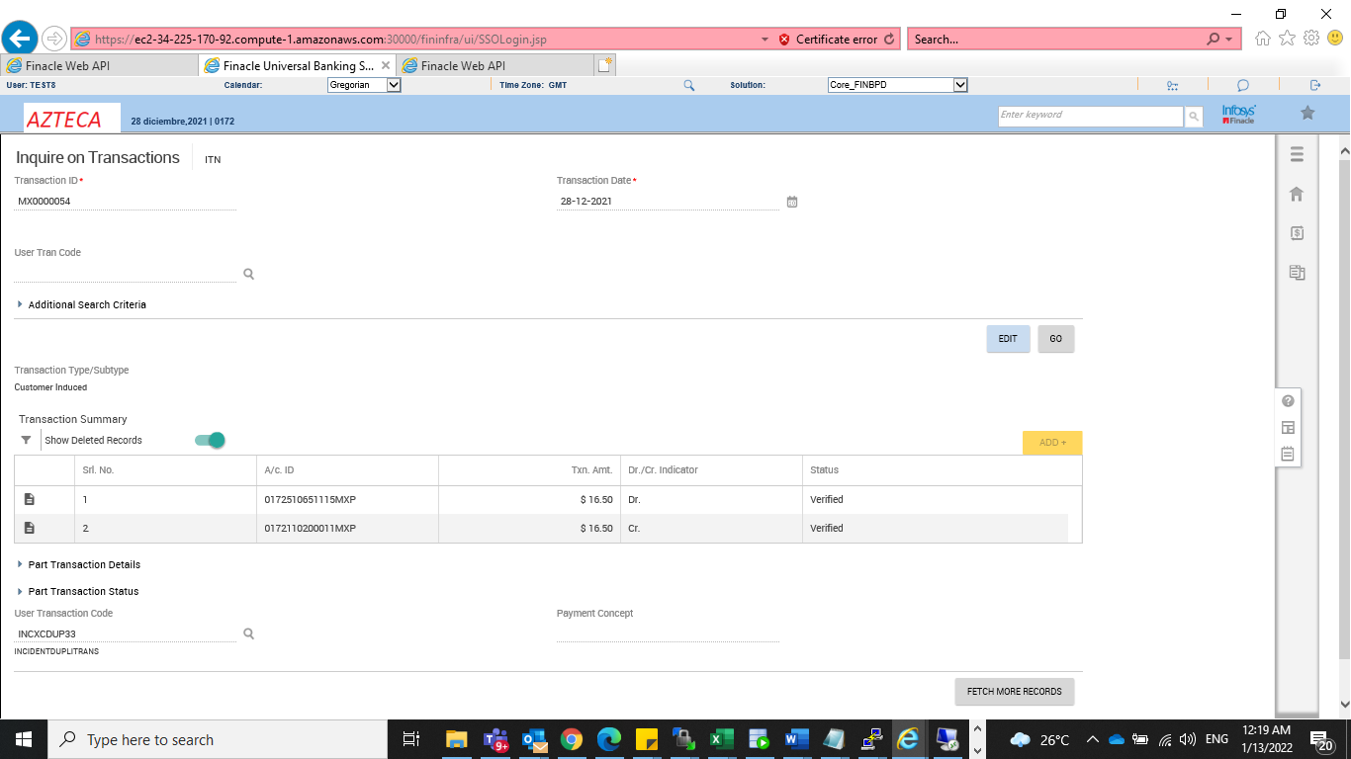

Duplicate transaction

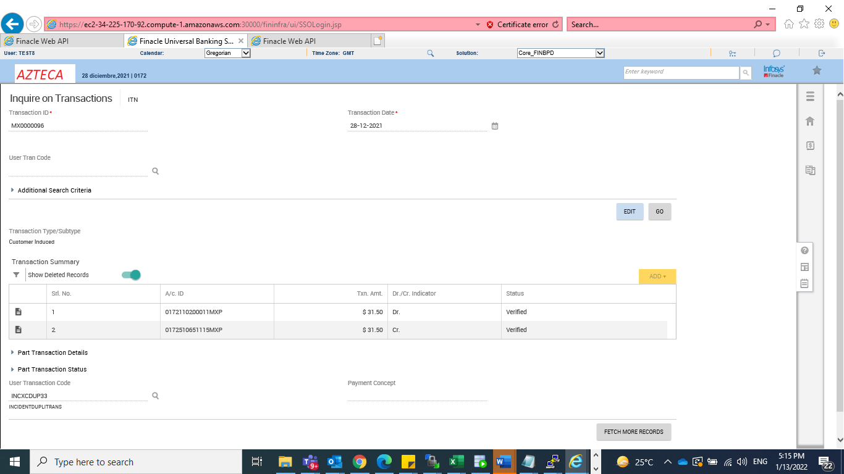

EGLO file processing

